**Project Report**

On

**“Airline Reservation System”**

Designed and Developed By

**Ms. VRUSHALI SHRIKANT SATAM**

For PARTIAL FULFILMENT for Degree of

**Bachelors of Science (COMPUTER SCIENCE)**

**UNIVERSITY OF MUMBAI**

**SEM V**

**2020-2021**

**UNDER THE GUIDANCE OF Prof. Poonam Pandey**

**S.K. Somaiya Degree College of Arts, Science and Commerce**

**VIDYAVIHAR (EAST)**

**MUMBAI-400 077**

**ACKNOWLEDGEMENT**

I have a great pleasure in representing this project report entitled “Airline Reservation System” and I grab this opportunity to convey my immense regards towards all the distinguished people who have their valuable contribution in the hour of need.

I would like to thank our honorable Principal Dr. MANALI LONDHE for granting us different facilities to do the project under the guidance of our faculty. Because to their support this project was a success.

I take this opportunity to thank Prof. Mrs. Poonam Pandey, Coordinator of the Department and all the professors of the Department of Computer Science of S.K. Somaiya Degree College of Arts Science & Commerce, for giving me an opportunity to complete this project and the most needed guidance throughout the duration of the programme.

I am extremely grateful to my project guide Prof. Poonam Pandey her valuable guidance and necessary support during each phase of the project. She was the source of continuous encouragement as each milestone was crossed.

A special thanks to the University Of Mumbai for having prescribed this project work to me as a part of the academic requirement in the Final year of Bachelor of Science in Computer Science.

Sincere thank from,

(Vrushali Satam)

**Index**

**____________________________________________________________________________**

|  |  |  |
| --- | --- | --- |
| **Sr. No.** | **Contents** | **Pg. No.** |
| 1 | Investigation | 4 |
|  | Project Title | 4 |
|  | Introduction | 4 |
|  | Scope of the Project | 5 |
| 2 | Analysis | 6 |
|  | Project History | 6 |
|  | Requirement Gathering | 6 |
|  | Objective and Existing System | 6 |
|  | Advantage of Proposed System | 7 |
|  | Feasibility Study | 7 |
|  | Requirement Specification | 8 |
|  | Tools & Technology | 10 |
| 3 | Design Phase | 11 |
|  | ER Diagram | 13 |
|  | Flow Chart | 14 |
|  | Class Diagram | 15 |
|  | Activity Diagram | 16 |
|  | Use Case Diagram | 17 |
|  | Sequence Diagram | 18 |
|  | Database Design | 19 |
| 4 | Screenshots of Application | 20 |
| 5 | Coding Phase | 29 |
| 6 | Testing Phase | 106 |
| 7 | Future Enhancement | 107 |
| 8 | References | 108 |

**Investigation**

**____________________________________________________________________________**

* **Title of the Project :**

Airline Reservation System

* **Introduction :**

### The system enables the customer to do things such as the search for airline flights for two travel cities on a specified date, choose a flight based on the details, reservation of flight, and cancellation of the reservation. The main purpose of this software is to reduce the manual errors involved in the airline reservation process and make it convenient for the customers to book the flights as when they require such that they can utilize this software to make reservations, modify reservations or cancel a particular reservation. The system allows the airline passenger to search for flights that are available between the two travel cities, namely the “Destination City” and “Source City” for a particular departure and arrival dates. The system displays all the flight details such as flight no, name, price and class, etc. After the search, the system displays a list of available flights and allows the customer to choose a particular flight. To book a flight, the system asks the customer to enter his details such as name, email address, and contact number. The system also allows the customer to cancel his/her reservation, if any problem occurs. The user can make payments through credit card or debit card. The customer can print the invoice as well.

* **Scope of the Project :**

### The system allows the airline passenger to search for flights that are available between the two travel cities, namely the “Departure city” and “Arrival city” for a particular departure and arrival dates. The system displays not all the flight details such as flight any, name, price and duration of the journey, etc. The name of the software is “AIRLINE RESERVATION SYSTEM.” This software provides options for viewing different flights available with varying timings for a particular date and provides customers with the facility to book a ticket modify or cancel a specific reservation.

### It satisfies the user requirement.

### Be easy to understand by the user and operator.

### Be easy to operate.

### Have a good user interface.

### Be expandable.

### Delivered on schedule within the budget.

* **Software Specifications:**

**Frontend:** Java NetBeans 8.0.2

**Backend:** MySQL 8.0

* **Hardware Specifications:**

Processor - Intel Core i3

Hard disk - 500GB

RAM - 8GB

Operating System – 64 – bit Windows 10

**Analysis**

**____________________________________________________________________________**

* **Project History :**

The purpose of the Airline Reservation System is to automate the existing manual system with the help of computerized equipment and full-fledged computer software, fulfilling their requirements, so that their valuable data/information can be stored for a longer period with easy access and manipulation of the same. The required software and hardware are easily available and easy to work with. This can lead to an error-free, secure, reliable, and fast management system. The project describes how to manage for good performance and better services for the clients.

* **Requirement Gathering :**

The requirements of the Airline Reservation System are divided between the Customer and the administrator of the application.

* **Objective and Existing System:**

The main objective of project on Airline Reservation System is to manage the details of airlines tickets, flights, bookings, customers. The project is to build on both ends administrative as well as customer, so both can access. The purpose of the project is to build an application program to reduce the manual work for managing airlines tickets, flights, bookings, customers. It tracks all details about the flights, bookings and customers.

* **Drawbacks:**

-Inability of passengers to select their preferred seat(s) from reservation system.

-Passenger do not have access to aircraft maintenance report.

-This application is costly.

-Need to be ready for an influx of new customers.

* **Objectives:**

-Create filters for flights.

-Easy and user-friendly interface.

-It tracks all the information of flights, bookings.

-All the fields such as airline tickets, customers are validated and does not take invalid values.

* **Advantages of Proposed System:**

-Avoiding local storage of data.

- Reduce the chance of losing data by hardware failure.

-Easy and friendly user interface.

-Reduce time.

-Minimize manual data entry.

-Greater efficiency.

-Better service.

-Billing will be easier (i.e. calculations).

* **Feasibility Study:**

Feasibility study includes consideration of all the possible ways to provide a solution to given problem. The proposed solution should satisfy all the user requirements and should be flexible enough so that future changes can be easily done based on the future upcoming requirements.

1. **Economic Feasibility**

This is very important aspect to be considered while developing a project. Decided the technology based on minimum possible cost factor. Overall estimated that the benefits the organization is going to receive from the proposed system will surely overcome the initial costs and the later on running cost for system.

1. **Technical Feasibility**

This included the study of function, performance and constraints that may affect the ability to achieve an acceptable system. For this feasibility study, studied complete functionality to be provided in the system, as described in the System Requirement Specification (SRS), and checked if everything was possible using different type of frontend and backend platforms.

1. **Operational Feasibility**

No doubt, the proposed system is fully GUI based that is very user friendly and all inputs to be taken all self- explanatory even to a nonprofessional. Besides, a proper training has been conducted to let know the essence of the system to the user so that they feel comfortable with new system. As far our study is concerned, the clients are comfortable and happy as the system has cut down their loads and doing.

* **Requirement Specification:**

1. Functional Requirements:
   * Admin

Adding Flights:

This action is done to add new flight.

Cancel/ Update Flights:

This event is to cancel an existing flight or modify its information.

Login:

Admin must be logged in before modify any information.

Sends Information to Customer:

Admin can send mail to the customer about the flight updating.

View Cancelled and Available Flights:

Admin can see the cancelled and available flights.

View Booked Flights:

Admin can see which customer has booked which flight.

* + Customer
    - 1. Login:

Customer must be logged in before booking or cancelling any ticket.

* + - 1. Register:

When new customer enters for the first time then he/she has to register.

* + - 1. Book Flights:

Customer can book flights.

* + - 1. Search Flights:

Customer can search for required flights.

* + - 1. Cancel Ticket:

Customer can cancel tickets.

* + - 1. Forgot Password:

If customer forgets his/her password, then he/she can change the password through this event.

* + - 1. Payment:

Customer can pay through credit card or debit card.

* + - 1. Invoice:

Customer can print his/her invoice.

* + Data Accessibility:
    - 1. Flight details are available.
      2. Profile details are not available.
  + System Security:
    - 1. Public has read only access via application.
      2. It provides read only data access.
    1. Non Functional Requirements:
  + Security:
    - 1. No user permission.
      2. It is secure for storing data.
  + Performance:
    - 1. Expecting performance.
  + Reliability:
    - 1. ARS will be available 24 hours per day, 7 days a week.
      2. ARS will be robust enough to have a high amount of fault tolerance.
  + Usability:
    - 1. ARS shall give an easy-to-use graphical program just like other existing booking system so the users do not have to learn a fresh style of conversation.
* **Tools and Technology:**
  + Software Specifications:

**Frontend:** Java NetBeans 8.0.2

**Backend:** MySQL 8.0

* + Hardware Specifications:

**Processor** - Intel Core i3

**Hard disk** - 500GB

**RAM** - 8GB

**Operating System** - 64 – bit Windows 10

**DESIGN PHASE**

**____________________________________________________________________________**

### **E-R Diagram**

An entity–relationship model describes interrelated things of interest in a specific domain of knowledge. A basic ER model is composed of entity types and specifies relationships that can exist between entities.

### **Flow Chart**

A flowchart is a type of diagram that represents a workflow or process. A flowchart can also be defined as a diagrammatic representation of an algorithm, a systematic approach to solving a task. The flowchart shows the steps as boxes of various kinds, and their order by connecting the boxes with arrows.

### **Class diagram**

A class diagram in the Unified Modeling Language is a type of static structure diagram that describes the structure of a system by showing the system's classes, their attributes, operations, and the relationships among objects.

**Activity Diagram**

The activity diagram used to describe flow of activity through a series of actions. Activity diagram is an important diagram to describe the system. The activity described as an action or operation of the system.

### **Use Case Diagram**

A use case diagram at its simplest is a representation of a user's interaction with the system that shows the relationship between the user and the different use cases in which the user is involved.

**Sequence diagram**

A sequence diagram shows object interactions arranged in time sequence. It depicts the objects involved in the scenario and the sequence of messages exchanged between the objects needed to carry out the functionality of the scenario. Sequence diagrams are typically associated with use case realizations in the Logical View of the system under development. Sequence diagrams are sometimes called event diagrams or event scenarios.

**Database design**

Database design is the organization of data according to a database model. The designer determines what data must be stored and how the data elements interrelate. With this information, they can begin to fit the data to the database model. Database management system manages the data accordingly.

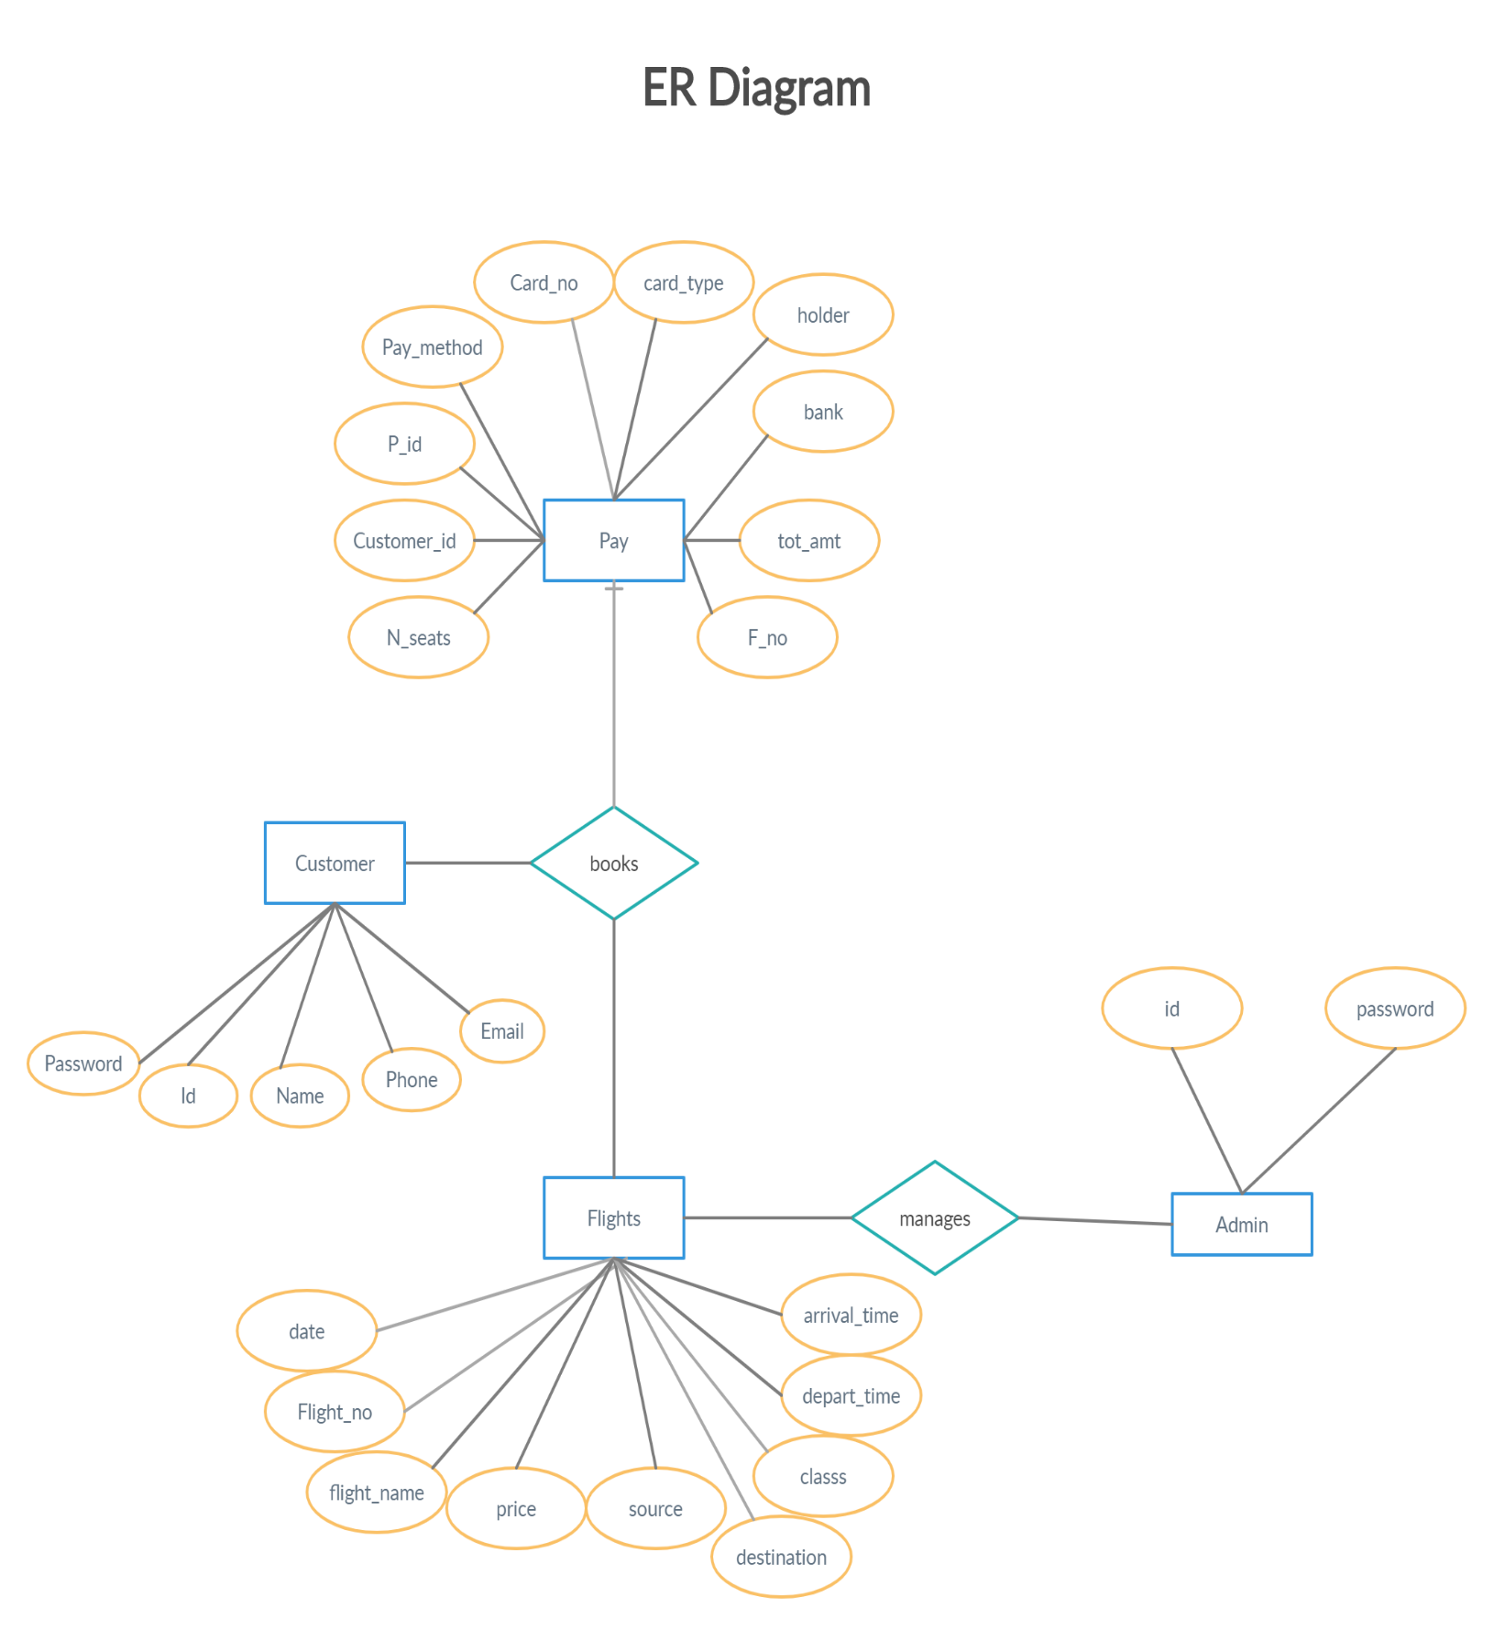 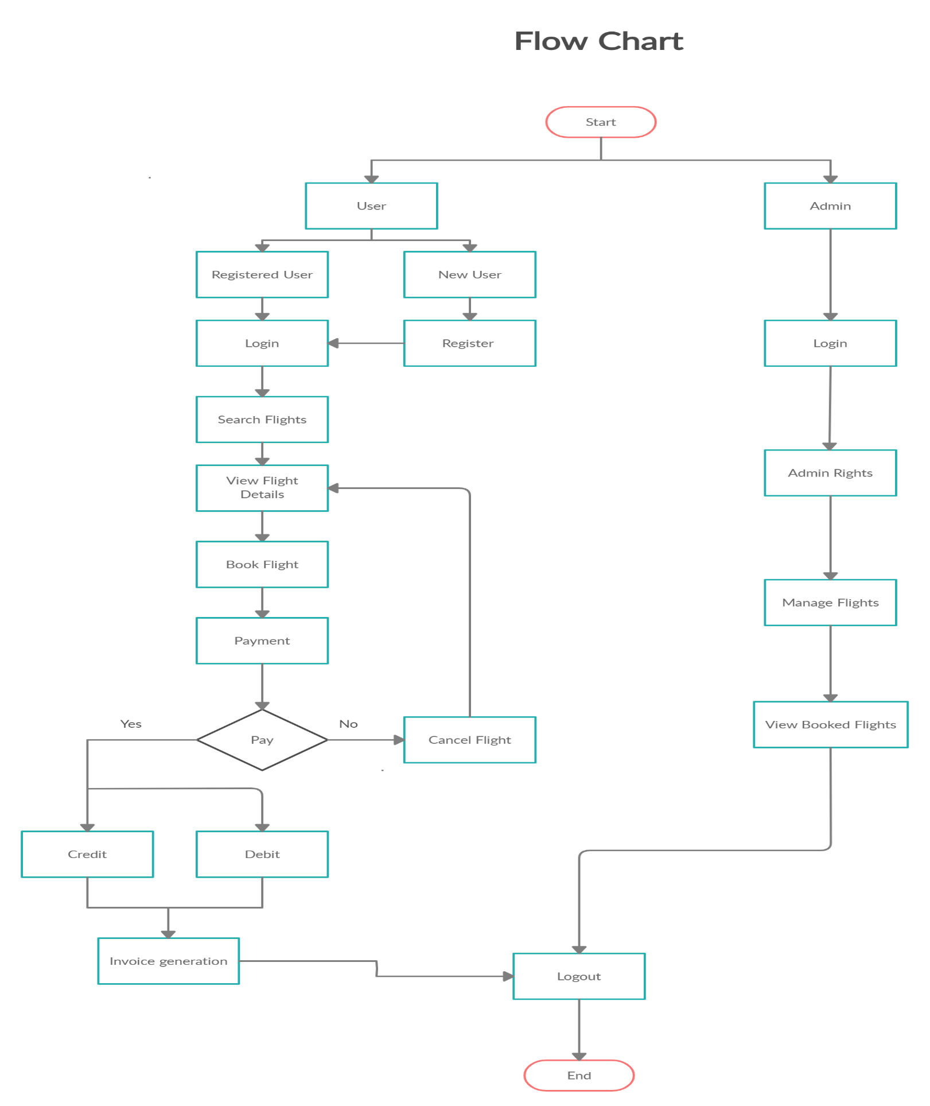

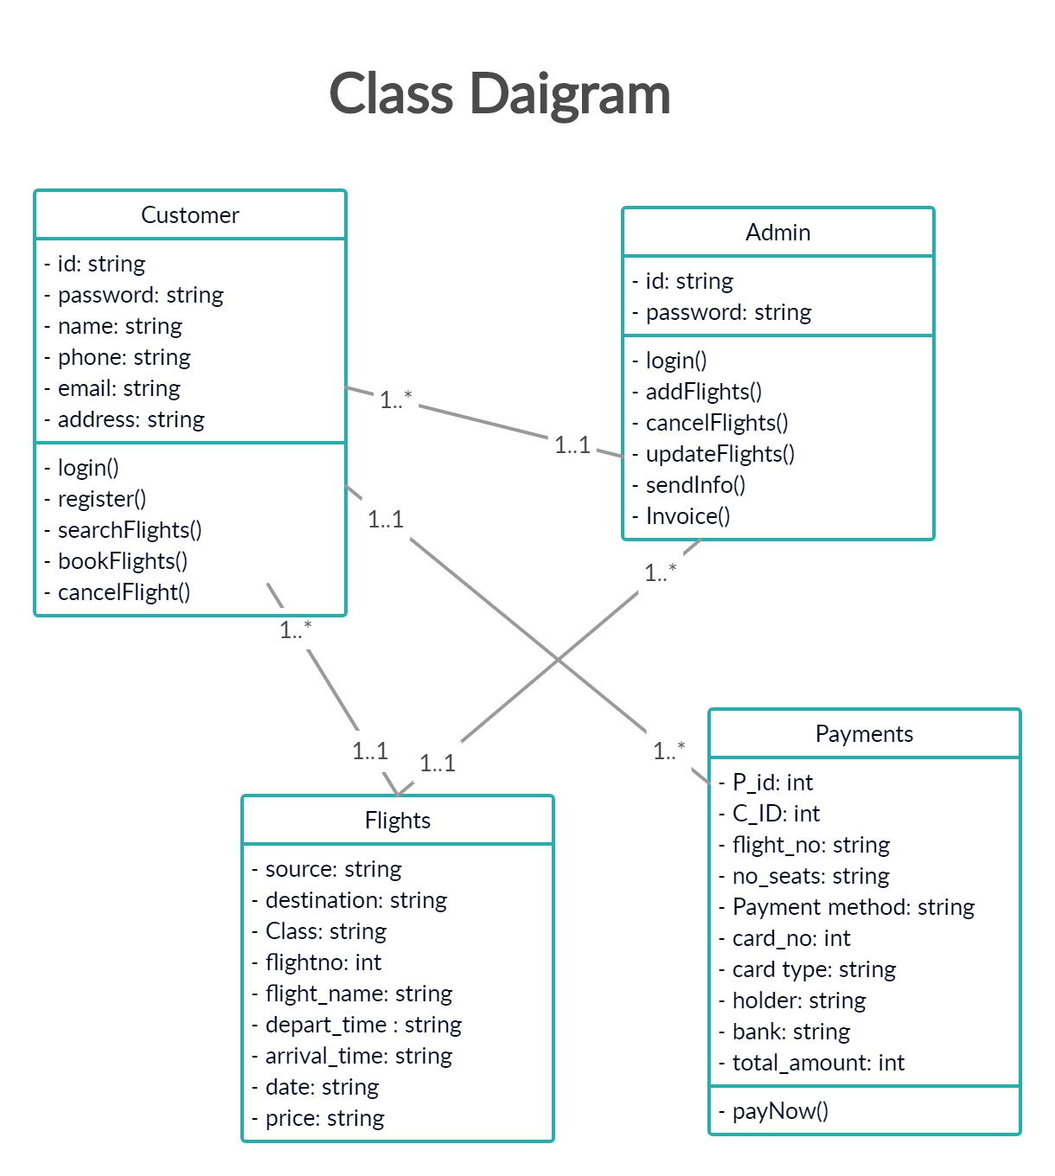 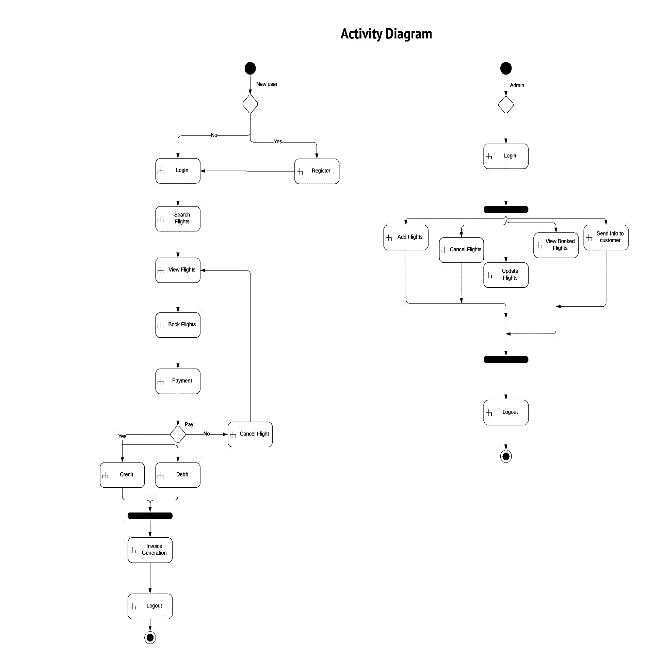

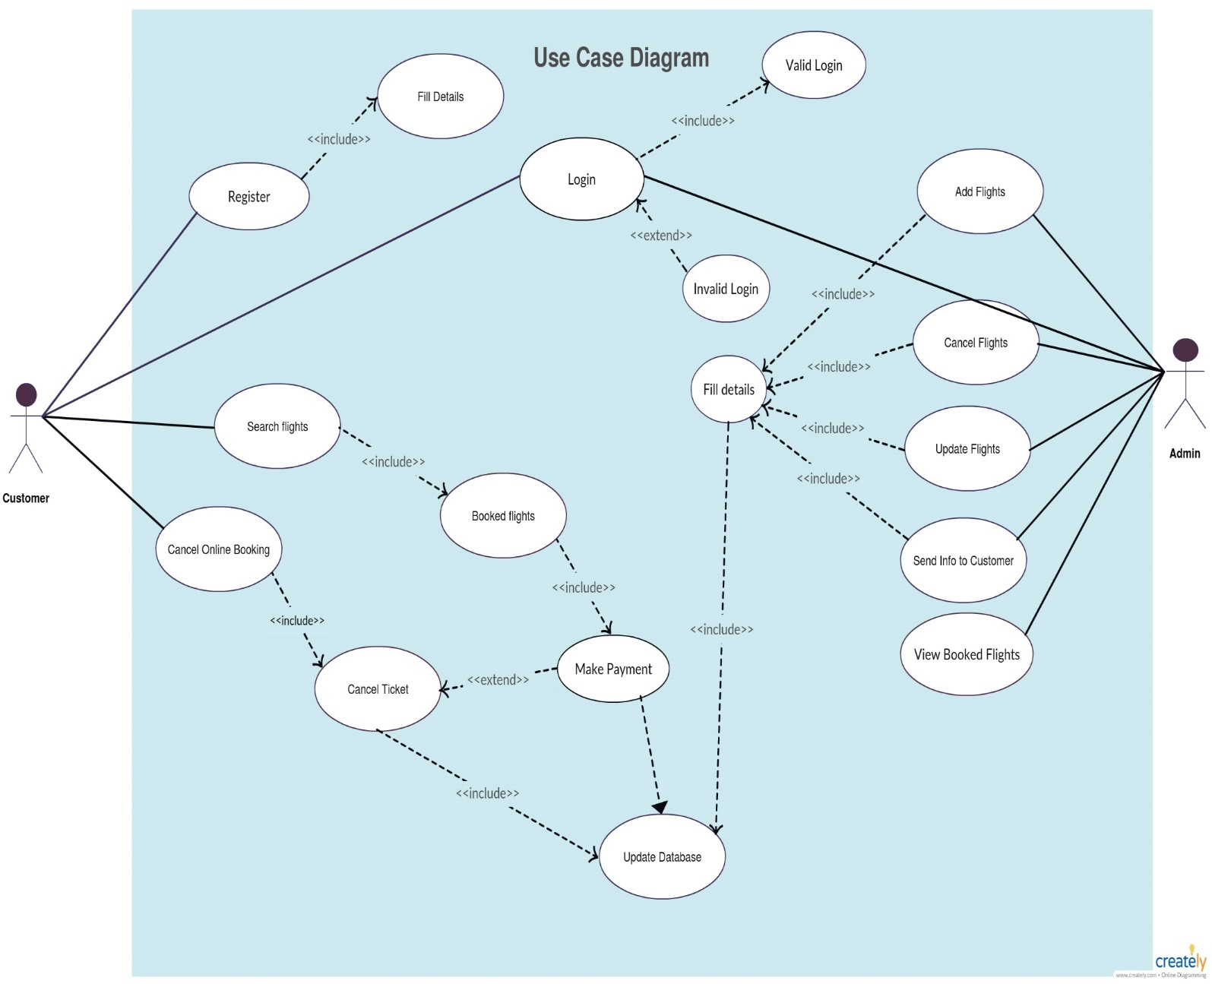

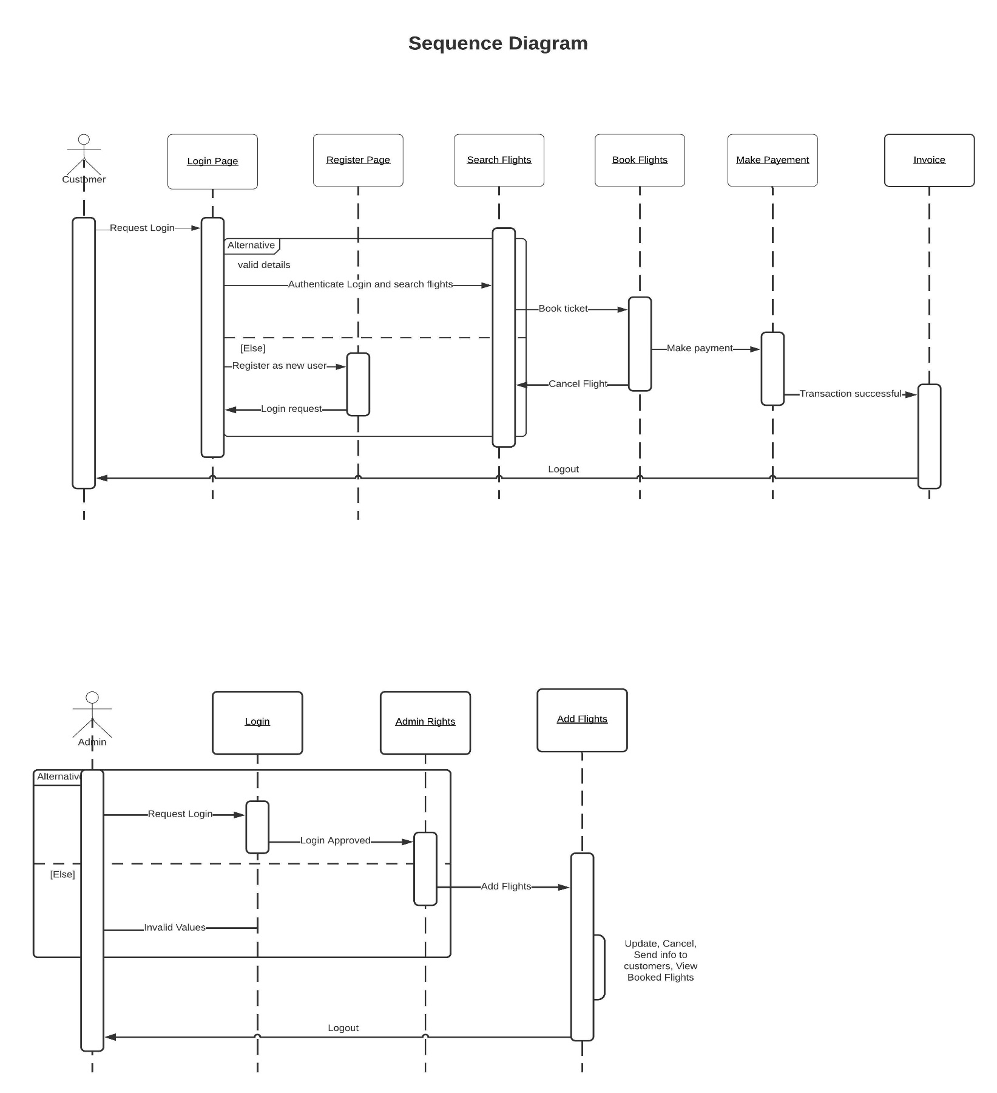 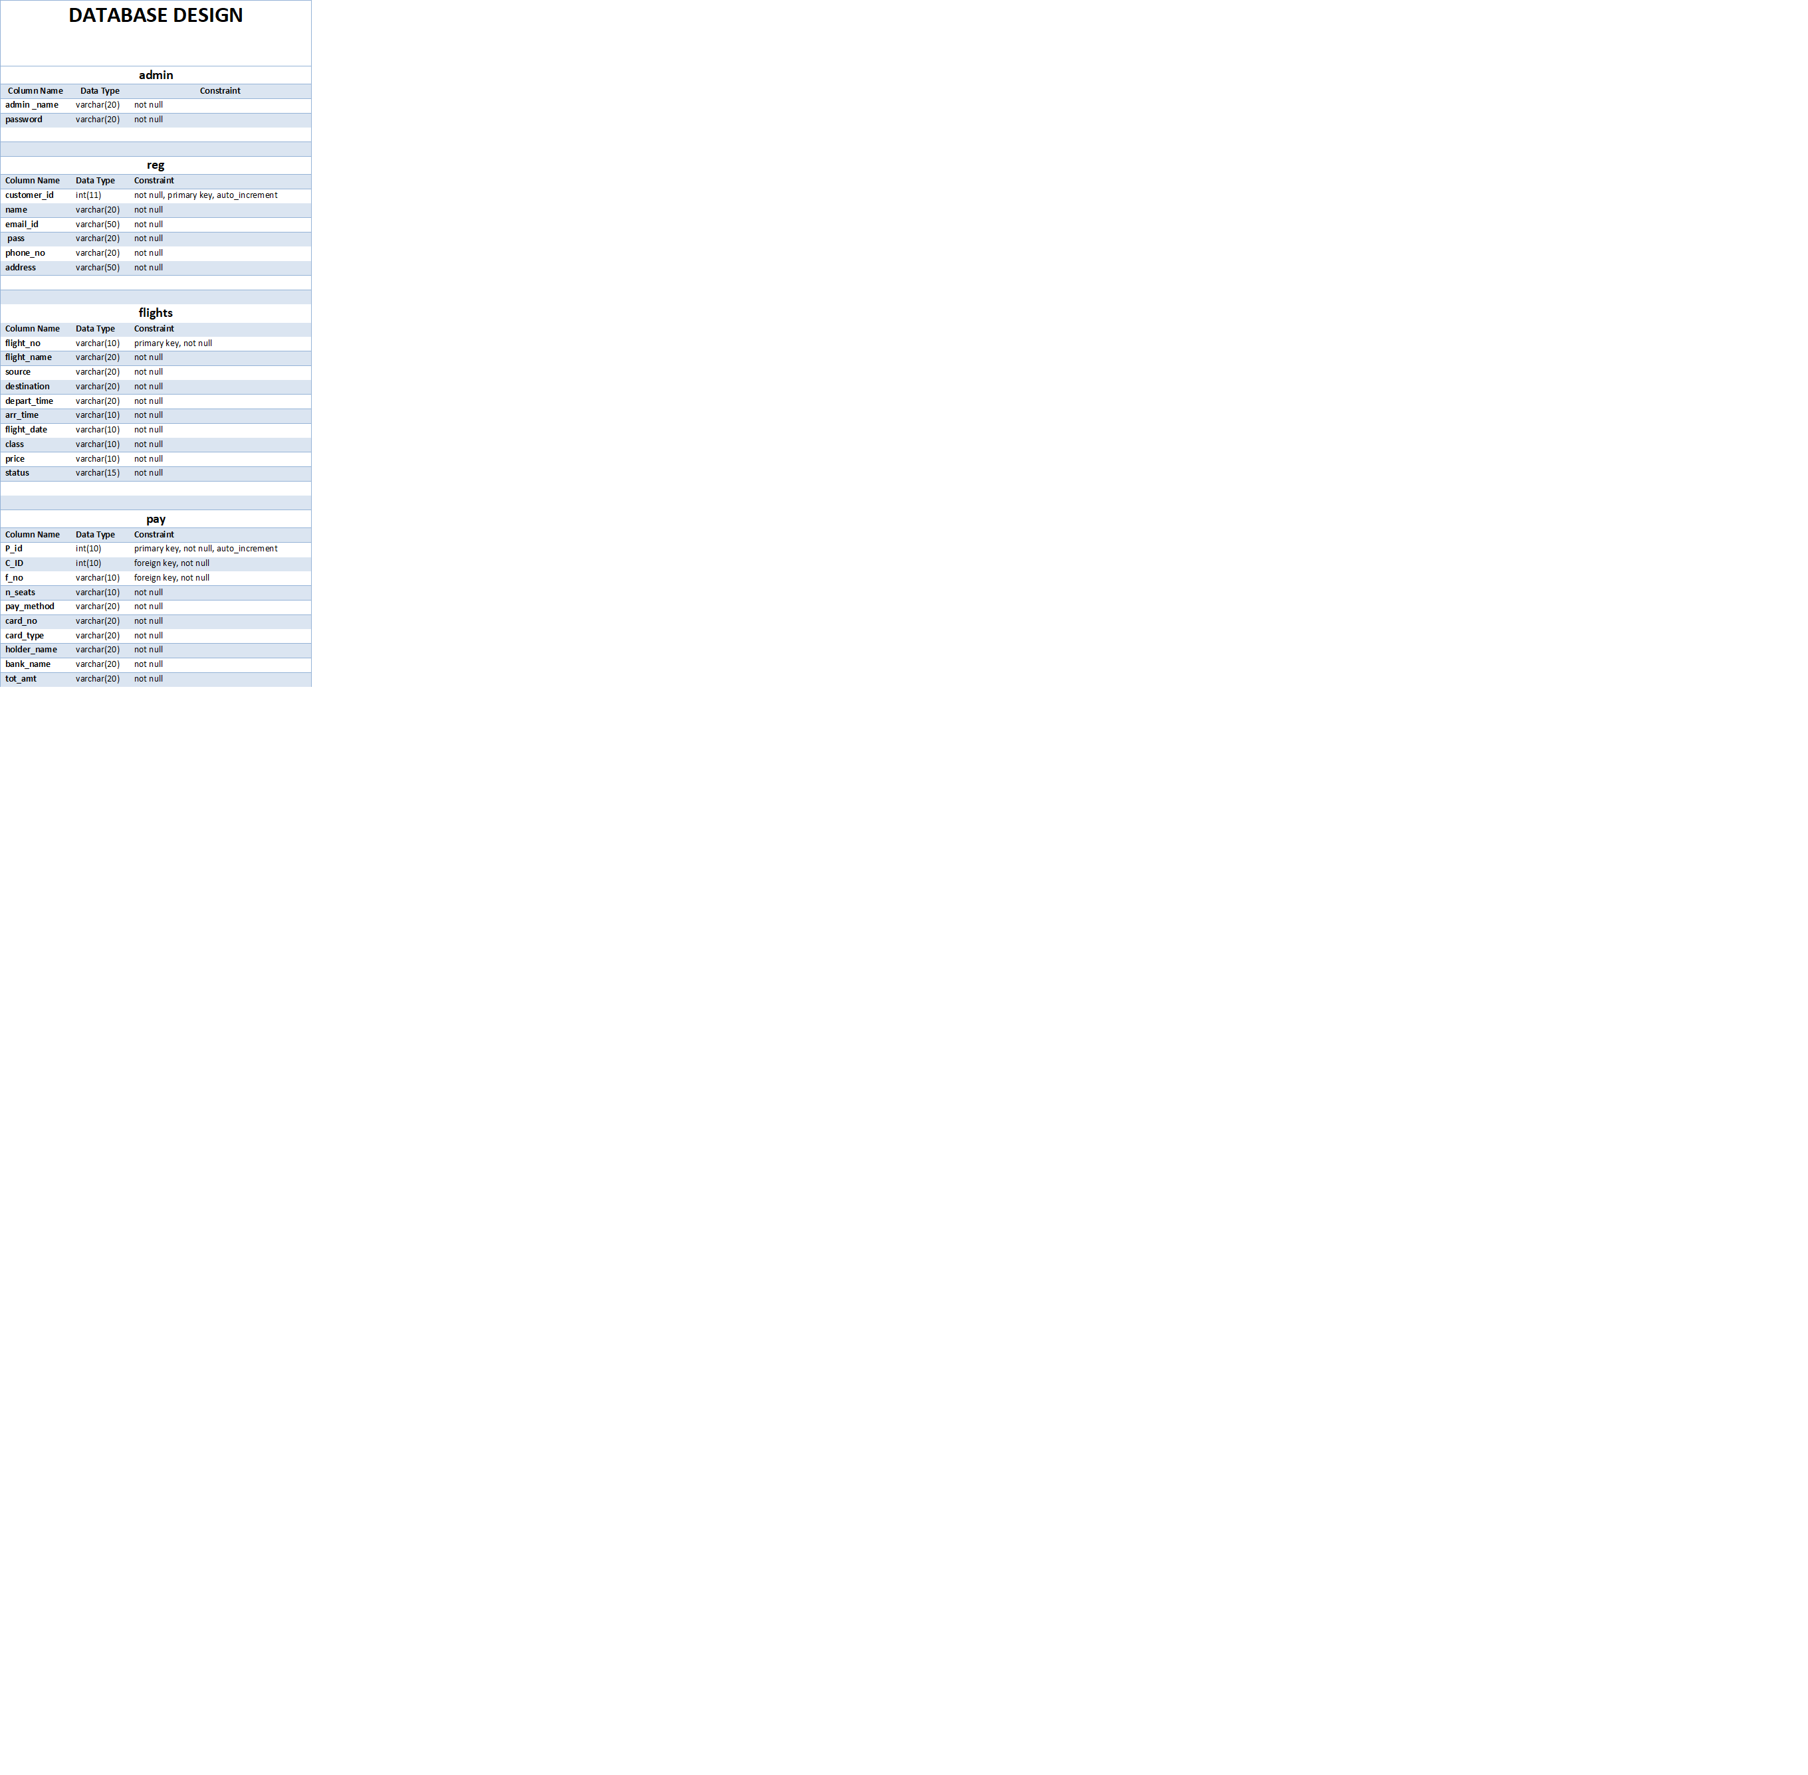

**Screenshots of Application**

**____________________________________________________________________________**

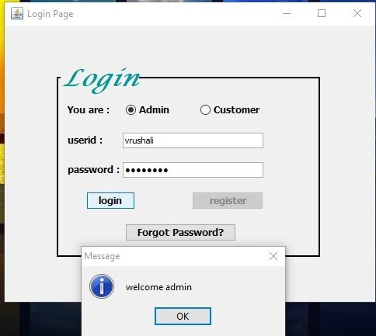

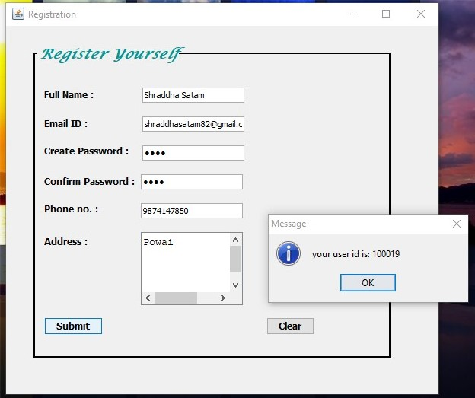

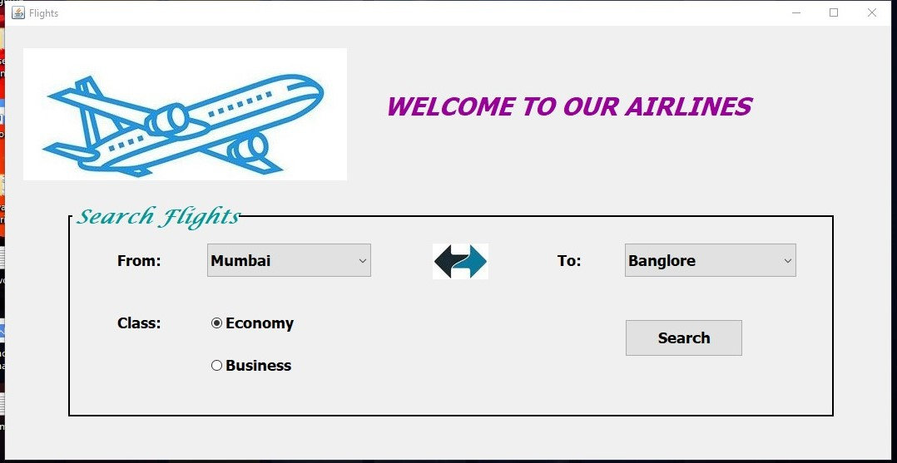

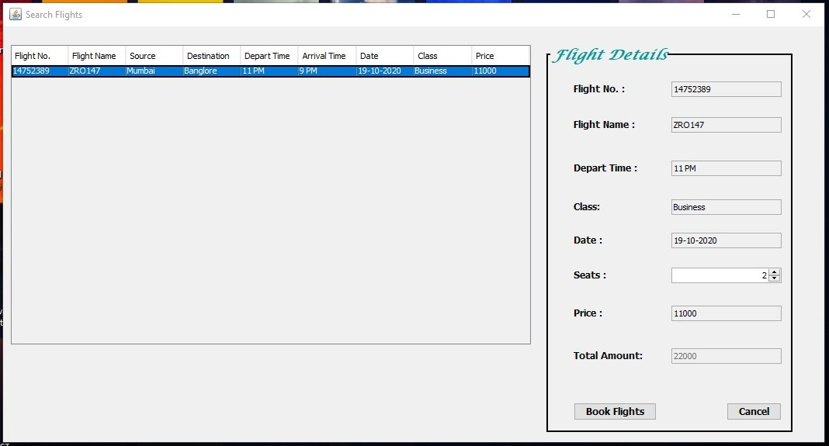

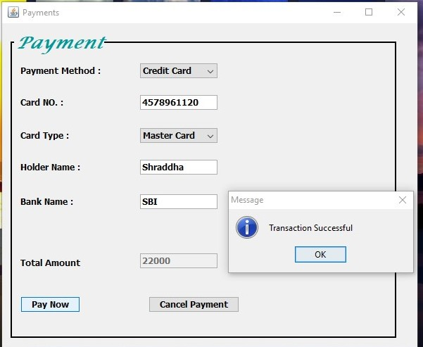

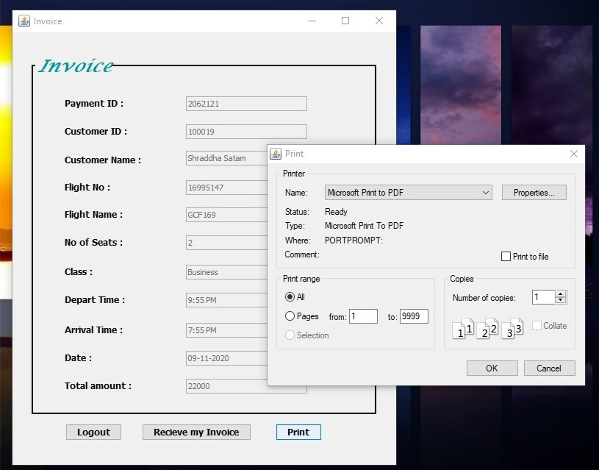

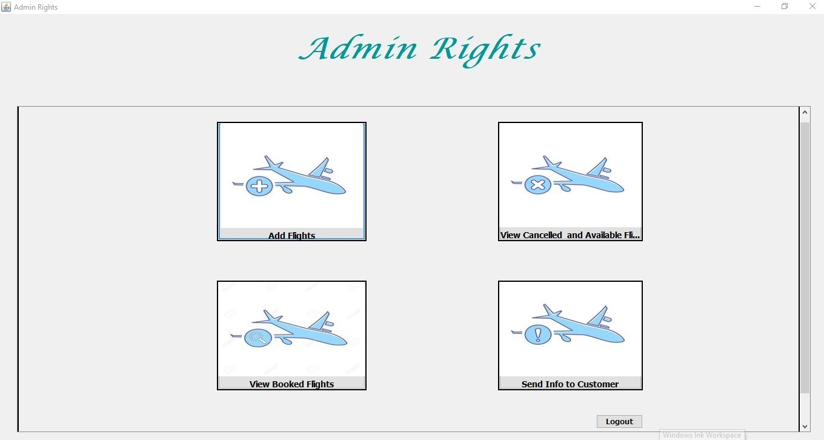

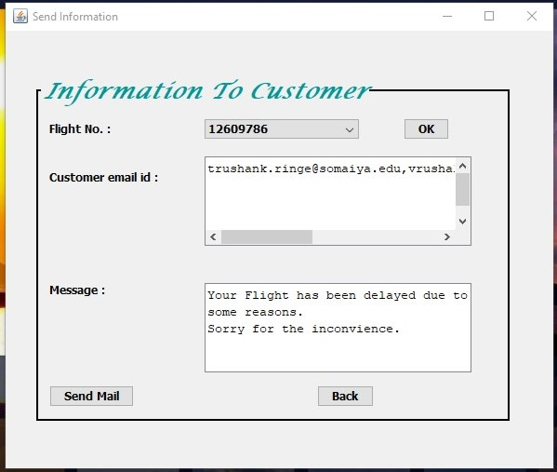

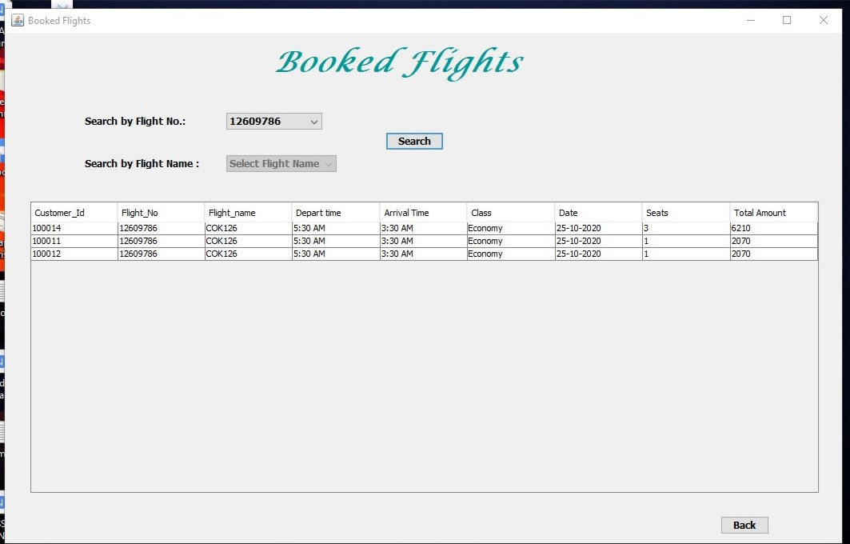

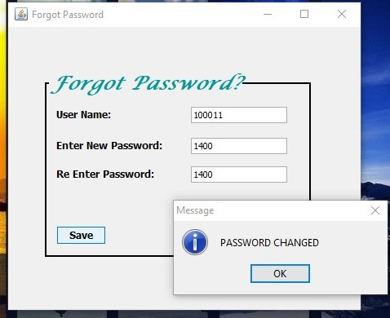

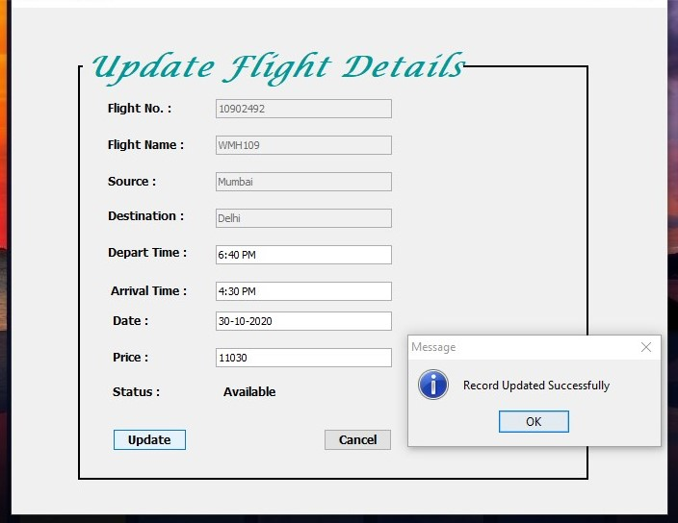

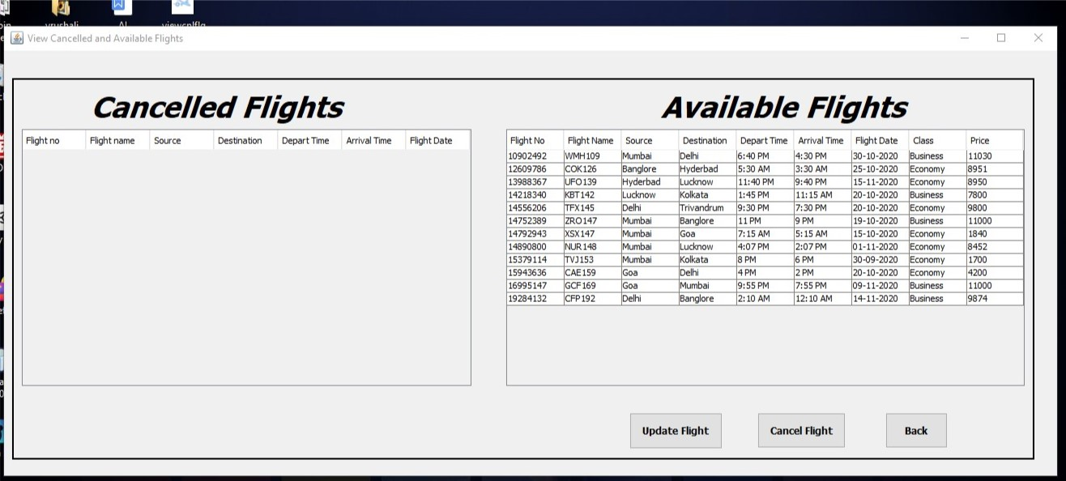

**CODING PHASE**

**____________________________________________________________________________**

**-Airline.java**

package airline;

public class Airline {

public static void main(String[] args) {

LoginForm lf = new LoginForm();

try {

for (javax.swing.UIManager.LookAndFeelInfo info : javax.swing.UIManager.getInstalledLookAndFeels()) {

if ("Windows".equals(info.getName())) {

javax.swing.UIManager.setLookAndFeel(info.getClassName());

break;

}

}

} catch (ClassNotFoundException | InstantiationException | IllegalAccessException | javax.swing.UnsupportedLookAndFeelException ex) {

java.util.logging.Logger.getLogger(Airline.class.getName()).log(java.util.logging.Level.SEVERE, null, ex);

}

lf.setVisible(true);

}

}

**-LoginForm.java**

package airline;

import java.awt.HeadlessException;

import java.awt.Toolkit;

import java.awt.event.WindowEvent;

import java.sql.*;

import javax.swing.*;

public class LoginForm extends javax.swing.JFrame {

PreparedStatement pst=null;

PreparedStatement pst1=null;

ResultSet rs, rs1 = null;

public LoginForm() {

super("RegForm");

initComponents();

setTitle("Login Page");

}

public void close(){

WindowEvent we = new WindowEvent(this,WindowEvent.WINDOW_CLOSING);

Toolkit.getDefaultToolkit().getSystemEventQueue().postEvent(we);

}

private void btnloginActionPerformed(java.awt.event.ActionEvent evt) {

String sql2="Select * from admin where admin_name=? and password=?";

String Sql="Select * from reg where customer_id=? and pass=?";

try{

Class.forName("com.mysql.cj.jdbc.Driver");

Connection conn = (Connection)DriverManager.getConnection("jdbc:mysql://localhost:3306/airline","root","mysql password");

pst=conn.prepareStatement(Sql);

pst1=conn.prepareStatement(sql2);

pst.setString(1,txtusername.getText());

pst1.setString(1,txtusername.getText());

char[] s1=txtpassword.getPassword();

char[] s2=txtpassword.getPassword();

String t1=new String(s1);

String t2=new String(s2);

pst.setString(2, t1);

pst1.setString(2, t2);

rs=pst.executeQuery();

rs1=pst1.executeQuery();

if(rs.next()){

JOptionPane.showMessageDialog(null,"welcome to our airlines");

Flight f=new Flight();

f.setVisible(true);

close();

}

else if(rs1.next()){

JOptionPane.showMessageDialog(null,"welcome admin");

AdminRights af = new AdminRights();

af.setVisible(true);

close();

}

else{

JOptionPane.showMessageDialog(null,"invalid username or password","Access denied",JOptionPane.ERROR_MESSAGE);

}

}

catch(ClassNotFoundException | SQLException | HeadlessException e){

JOptionPane.showMessageDialog(null, e);

}

}

private void btnregActionPerformed(java.awt.event.ActionEvent evt) {

RegForm rf=new RegForm("Vrushali's Airline Registration Form");

rf.setVisible(true);

close();

}

private void jRadioButton1ActionPerformed(java.awt.event.ActionEvent evt) {

// TODO add your handling code here:

jRadioButton1.setSelected(true);

if(jRadioButton1.isSelected())

{

btnreg.setEnabled(false);

}

}

private void jRadioButton2ActionPerformed(java.awt.event.ActionEvent evt) {

// TODO add your handling code here:

btnreg.setEnabled(true);

}

private void jButton1ActionPerformed(java.awt.event.ActionEvent evt) {

// TODO add your handling code here:

ForgotPassword fp = new ForgotPassword();

fp.setVisible(true);

close();

}

public static void main(String args[]) {

java.awt.EventQueue.invokeLater(() -> {

new LoginForm().setVisible(true);

});

}

private javax.swing.JButton btnlogin;

private javax.swing.JButton btnreg;

private javax.swing.ButtonGroup buttonGroup1;

private javax.swing.JButton jButton1;

private javax.swing.JLabel jLabel1;

private javax.swing.JLabel jLabel2;

private javax.swing.JLabel jLabel3;

private javax.swing.JPanel jPanel1;

private javax.swing.JPanel jPanel2;

private javax.swing.JRadioButton jRadioButton1;

private javax.swing.JRadioButton jRadioButton2;

private javax.swing.JPasswordField txtpassword;

public static javax.swing.JTextField txtusername;

}

**-ForgotPassword.java**

package airline;

import java.awt.Toolkit;

import java.awt.event.WindowEvent;

import java.sql.Connection;

import java.sql.DriverManager;

import java.sql.PreparedStatement;

import java.sql.ResultSet;

import java.sql.SQLException;

import java.util.logging.Level;

import java.util.logging.Logger;

import javax.swing.JOptionPane;

public class ForgotPassword extends javax.swing.JFrame {

PreparedStatement pst;

ResultSet rs;

public ForgotPassword() {

initComponents();

}

public void close(){

WindowEvent we = new WindowEvent(this,WindowEvent.WINDOW_CLOSING);

Toolkit.getDefaultToolkit().getSystemEventQueue().postEvent(we);

}

private void jTextField1KeyReleased(java.awt.event.KeyEvent evt) {

// TODO add your handling code here:

try {

Class.forName("com.mysql.cj.jdbc.Driver");

Connection con = DriverManager.getConnection("jdbc:mysql://localhost:3306/airline?allowMultiQueries=true", "root", "mysql password");

String sql = "SELECT customer_id FROM reg WHERE customer_id=?";

pst = con.prepareStatement(sql);

pst.setString(1, jTextField1.getText());

rs = pst.executeQuery();

if (rs.next())

{

jLabel4.setText("");

}

else {

jLabel4.setText("Username Not Found");

}

} catch (ClassNotFoundException | SQLException e) {

JOptionPane.showMessageDialog(null, e);

}

}

private void jButton1ActionPerformed(java.awt.event.ActionEvent evt) {

// TODO add your handling code here:

try

{

Class.forName("com.mysql.cj.jdbc.Driver");

Connection con = DriverManager.getConnection("jdbc:mysql://localhost:3306/airline?allowMultiQueries=true", "root", "mysql password");

String sql="update reg set pass='"+jTextField2.getText()+"' where customer_id='"+jTextField1.getText()+"'";

pst=con.prepareStatement(sql);

pst.execute();

JOptionPane.showMessageDialog(null, "PASSWORD CHANGED");

LoginForm lf=new LoginForm();

lf.setVisible(true);

close();

}

catch (ClassNotFoundException | SQLException ex) {

Logger.getLogger(ForgotPassword.class.getName()).log(Level.SEVERE, null, ex);

}

}

private void jTextField3KeyReleased(java.awt.event.KeyEvent evt) {

// TODO add your handling code here:

String rp=jTextField2.getText();

if(jTextField3.getText().equals(rp))

{

jLabel4.setText("");

}

else

{

jLabel4.setText("PASSWORD DOES NOT MATCH");

}

}

private void jButton2ActionPerformed(java.awt.event.ActionEvent evt) {

// TODO add your handling code here:

LoginForm lf = new LoginForm();

lf.setVisible(true);

close();

}

public static void main(String args[]) {

java.awt.EventQueue.invokeLater(new Runnable() {

public void run() {

new ForgotPassword().setVisible(true);

}

});

}

private javax.swing.JButton jButton1;

private javax.swing.JButton jButton2;

private javax.swing.JLabel jLabel1;

private javax.swing.JLabel jLabel2;

private javax.swing.JLabel jLabel3;

private javax.swing.JLabel jLabel4;

private javax.swing.JPanel jPanel1;

private javax.swing.JTextField jTextField1;

private javax.swing.JTextField jTextField2;

private javax.swing.JTextField jTextField3;

}

**-RegForm.java**

package airline;

import javax.swing.*;

import java.awt.*;

import java.awt.event.WindowEvent;

import java.sql.*;

public class RegForm extends javax.swing.JFrame {

PreparedStatement ps, pst = null;

ResultSet rss=null;

public RegForm(String title)

{

initComponents();

}

public void close(){

WindowEvent we = new WindowEvent(this,WindowEvent.WINDOW_CLOSING);

Toolkit.getDefaultToolkit().getSystemEventQueue().postEvent(we);

}

private void submitActionPerformed(java.awt.event.ActionEvent evt) {

// TODO add your handling code here:

if(evt.getSource()==submit)

{

String num=jTextField3.getText();

int x=0;

char[] s1=jPasswordField1.getPassword();

String t3=new String(s1);

char[] s2=jPasswordField2.getPassword();

String t4=new String(s2);

if(t3.equals(t4))

{

if(num.matches("^[0-9]*$") && num.length()==10)

{

try

{

Class.forName("com.mysql.cj.jdbc.Driver");

Connection con = DriverManager.getConnection("jdbc:mysql://localhost:3306/airline?allowMultiQueries=true", "root", "mysql password");

ps = con.prepareStatement("insert into reg (NAME, email_id, pass, phone_no, address) values(?,?,?,?,?)");

ps.setString(1, jTextField1.getText());

ps.setString(2, jTextField2.getText());

ps.setString(3, t3);

ps.setString(4, jTextField3.getText());

ps.setString(5, jTextArea1.getText());

ps.executeUpdate();

x++;

if (x > 0)

{

JOptionPane.showMessageDialog(submit, "Data Saved Successfully");

String Sql= "select customer_id from reg where name=?";

pst=con.prepareStatement(Sql);

pst.setString(1,jTextField1.getText());

rss = pst.executeQuery();

while (rss.next()) {

String data = rss.getString(1);

data = rss.getString("customer_id");

JOptionPane.showMessageDialog(submit, "your user id is: "+ data);

close();

}

LoginForm f=new LoginForm();

f.setVisible(true);

}

}

catch(ClassNotFoundException | SQLException | HeadlessException ex)

{

System.out.println(ex);

}

}

}

else

{

JOptionPane.showMessageDialog(submit, "Password Does Not Match OR Your Phone Number is Invalid");

}

}

private void clearActionPerformed(java.awt.event.ActionEvent evt) {

// TODO add your handling code here:

jTextField1.setText("");

jTextField2.setText("");

jPasswordField1.setText("");

jPasswordField2.setText("");

jTextField3.setText("");

LoginForm lf = new LoginForm();

lf.setVisible(true);

close();

}

public static void main(String args[]) {

try {

for (javax.swing.UIManager.LookAndFeelInfo info : javax.swing.UIManager.getInstalledLookAndFeels()) {

if ("Windows".equals(info.getName())) {

javax.swing.UIManager.setLookAndFeel(info.getClassName());

break;

}

}

} catch (ClassNotFoundException | InstantiationException | IllegalAccessException | javax.swing.UnsupportedLookAndFeelException ex) {

java.util.logging.Logger.getLogger(RegForm.class.getName()).log(java.util.logging.Level.SEVERE, null, ex);

}

RegForm re=new RegForm("Vrushali's Airline Reservation");

java.awt.EventQueue.invokeLater(() -> {

re.setVisible(true);

});

}

private javax.swing.JButton clear;

private javax.swing.JLabel jLabel1;

private javax.swing.JLabel jLabel2;

private javax.swing.JLabel jLabel3;

private javax.swing.JLabel jLabel4;

private javax.swing.JLabel jLabel5;

private javax.swing.JLabel jLabel6;

private javax.swing.JPanel jPanel1;

private javax.swing.JPasswordField jPasswordField1;

private javax.swing.JPasswordField jPasswordField2;

private javax.swing.JScrollPane jScrollPane1;

private javax.swing.JTextArea jTextArea1;

public static javax.swing.JTextField jTextField1;

private javax.swing.JTextField jTextField2;

private javax.swing.JTextField jTextField3;

private javax.swing.JButton submit;

}

**-Flight.java**

package airline;

import java.awt.Toolkit;

import java.awt.event.WindowEvent;

import java.sql.Connection;

import java.sql.DriverManager;

import java.sql.PreparedStatement;

import java.sql.ResultSet;

import java.sql.ResultSetMetaData;

import java.sql.SQLException;

import java.util.Vector;

import java.util.logging.Level;

import java.util.logging.Logger;

import javax.swing.table.DefaultTableModel;

public class Flight extends javax.swing.JFrame {

ResultSet rs = null;

public Flight() {

initComponents();

}

public void close(){

WindowEvent we = new WindowEvent(this,WindowEvent.WINDOW_CLOSING);

Toolkit.getDefaultToolkit().getSystemEventQueue().postEvent(we);

}

private void searchFlightsActionPerformed(java.awt.event.ActionEvent evt) {

// TODO add your handling code here:

SearchedFlights sf = new SearchedFlights();

sf.setVisible(true);

DefaultTableModel df = (DefaultTableModel)sf.jTable2.getModel();

df.setRowCount(0);

try{

Class.forName("com.mysql.cj.jdbc.Driver");

Connection con = (Connection)DriverManager.getConnection("jdbc:mysql://localhost:3306/airline","root","mysql password");

if(jRadioButton1.isSelected())

{

PreparedStatement pst = con.prepareStatement("SELECT * from flights WHERE source = ? and destination = ? and status = 'Available' and class = '" + jRadioButton1.getText() + "'");

pst.setString(1, jComboBox2.getSelectedItem().toString().trim());

pst.setString(2, jComboBox1.getSelectedItem().toString().trim());

rs = pst.executeQuery();

ResultSetMetaData rsm = rs.getMetaData();

int c;

c = rsm.getColumnCount();

while(rs.next())

{

Vector v2 = new Vector();

for(int i = 1; i<= c; i ++)

{

v2.add(rs.getString("flight_no"));

v2.add(rs.getString("flight_name"));

v2.add(rs.getString("source"));

v2.add(rs.getString("destination"));

v2.add(rs.getString("depart_time"));

v2.add(rs.getString("arr_time"));

v2.add(rs.getString("flight_date"));

v2.add(rs.getString("class"));

v2.add(rs.getString("price"));

}

df.addRow(v2);

}

}

else if(jRadioButton2.isSelected())

{

PreparedStatement pst = con.prepareStatement("SELECT * from flights WHERE source = ? and destination = ? and status = 'Available' and class = '" + jRadioButton2.getText() + "'");

pst.setString(1, jComboBox2.getSelectedItem().toString().trim());

pst.setString(2, jComboBox1.getSelectedItem().toString().trim());

rs = pst.executeQuery();

ResultSetMetaData rsm = rs.getMetaData();

int c;

c = rsm.getColumnCount();

while(rs.next())

{

Vector v2 = new Vector();

for(int i = 1; i<= c; i ++)

{

v2.add(rs.getString("flight_no"));

v2.add(rs.getString("flight_name"));

v2.add(rs.getString("source"));

v2.add(rs.getString("destination"));

v2.add(rs.getString("depart_time"));

v2.add(rs.getString("arr_time"));

v2.add(rs.getString("flight_date"));

v2.add(rs.getString("class"));

v2.add(rs.getString("price"));

}

df.addRow(v2);

}

}

close();

}

catch (ClassNotFoundException | SQLException ex) {

Logger.getLogger(Flight.class.getName()).log(Level.SEVERE, null, ex);

}

}

public static void main(String args[]) {

java.awt.EventQueue.invokeLater(() -> {

new Flight().setVisible(true);

});

}

private javax.swing.ButtonGroup buttonGroup1;

private javax.swing.JComboBox jComboBox1;

private javax.swing.JComboBox jComboBox2;

private javax.swing.JLabel jLabel1;

private javax.swing.JLabel jLabel2;

private javax.swing.JLabel jLabel3;

private javax.swing.JLabel jLabel4;

private javax.swing.JLabel jLabel5;

private javax.swing.JLabel jLabel6;

private javax.swing.JPanel jPanel1;

private javax.swing.JRadioButton jRadioButton1;

private javax.swing.JRadioButton jRadioButton2;

private javax.swing.JButton searchFlights;

}

**-SearchedFlights.java**

package airline;

import java.awt.Toolkit;

import java.awt.event.WindowEvent;

import java.sql.PreparedStatement;

import java.sql.ResultSet;

import javax.swing.table.DefaultTableModel;

public class SearchedFlights extends javax.swing.JFrame {

PreparedStatement ps, pss, pst = null;

ResultSet rs, rss, rst=null;

String CId, CEId, At;

public SearchedFlights() {

initComponents();

}

public void close(){

WindowEvent we = new WindowEvent(this,WindowEvent.WINDOW_CLOSING);

Toolkit.getDefaultToolkit().getSystemEventQueue().postEvent(we);

}

private void jButton4ActionPerformed(java.awt.event.ActionEvent evt) {

// TODO add your handling code here:

Flight fs=new Flight();

fs.setVisible(true);

close();

}

private void jTable2MouseClicked(java.awt.event.MouseEvent evt) {

// TODO add your handling code here:

DefaultTableModel model=(DefaultTableModel) jTable2.getModel();

int selectIndex=jTable2.getSelectedRow();

jTextField1.setText(model.getValueAt(selectIndex, 0).toString());

jTextField2.setText(model.getValueAt(selectIndex, 1).toString());

jTextField3.setText(model.getValueAt(selectIndex, 4).toString());

jTextField4.setText(model.getValueAt(selectIndex, 7).toString());

jTextField5.setText(model.getValueAt(selectIndex, 6).toString());

jTextField6.setText(model.getValueAt(selectIndex, 8).toString());

}

private void incresepriceStateChanged(javax.swing.event.ChangeEvent evt) {

// TODO add your handling code here:

int price = Integer.parseInt(jTextField6.getText());

int qty = Integer.parseInt(jSpinner1.getValue().toString());

int tot = price * qty;

jTextField7.setText(String.valueOf(tot));

}

private void jButton1ActionPerformed(java.awt.event.ActionEvent evt) {

// TODO add your handling code here:

if(evt.getSource() == jButton1)

{

Payments py = new Payments();

Payments.jTextField4.setText(jTextField7.getText());

py.setVisible(true);

close();

}

}

public static void main(String args[]) {

try {

for (javax.swing.UIManager.LookAndFeelInfo info : javax.swing.UIManager.getInstalledLookAndFeels()) {

if ("Windows".equals(info.getName())) {

javax.swing.UIManager.setLookAndFeel(info.getClassName());

break;

}

}

} catch (ClassNotFoundException | InstantiationException | IllegalAccessException | javax.swing.UnsupportedLookAndFeelException ex) {

java.util.logging.Logger.getLogger(SearchedFlights.class.getName()).log(java.util.logging.Level.SEVERE, null, ex);

}

java.awt.EventQueue.invokeLater(() -> {

new SearchedFlights().setVisible(true);

});

}

private javax.swing.JButton jButton1;

private javax.swing.JButton jButton4;

private javax.swing.JLabel jLabel1;

private javax.swing.JLabel jLabel2;

private javax.swing.JLabel jLabel4;

private javax.swing.JLabel jLabel5;

private javax.swing.JLabel jLabel6;

private javax.swing.JLabel jLabel7;

private javax.swing.JLabel jLabel8;

private javax.swing.JLabel jLabel9;

private javax.swing.JPanel jPanel1;

private javax.swing.JScrollPane jScrollPane2;

public static javax.swing.JSpinner jSpinner1;

public javax.swing.JTable jTable2;

public static javax.swing.JTextField jTextField1;

public static javax.swing.JTextField jTextField2;

public static javax.swing.JTextField jTextField3;

public static javax.swing.JTextField jTextField4;

public static javax.swing.JTextField jTextField5;

public static javax.swing.JTextField jTextField6;

public static javax.swing.JTextField jTextField7;

}

**-Payments.java**

package airline;

import java.awt.HeadlessException;

import java.awt.Toolkit;

import java.awt.event.WindowEvent;

import java.sql.Connection;

import java.sql.DriverManager;

import java.sql.PreparedStatement;

import java.sql.ResultSet;

import java.sql.SQLException;

import java.util.Properties;

import java.util.logging.Level;

import java.util.logging.Logger;

import javax.mail.Message;

import javax.mail.MessagingException;

import javax.mail.PasswordAuthentication;

import javax.mail.Session;

import javax.mail.Transport;

import javax.mail.internet.InternetAddress;

import javax.mail.internet.MimeMessage;

import javax.swing.JOptionPane;

public class Payments extends javax.swing.JFrame {

PreparedStatement ps, pss, pst, pstt, pstmt= null;

ResultSet rs, rss, rst, rst1, rst2=null;

String CId, CIdd, sql;

Connection con;

public Payments() {

initComponents();

}

public void close(){

WindowEvent we = new WindowEvent(this,WindowEvent.WINDOW_CLOSING);

Toolkit.getDefaultToolkit().getSystemEventQueue().postEvent(we);

}

private void payNowActionPerformed(java.awt.event.ActionEvent evt) {

Invoice ic = new Invoice();

if(evt.getSource() == payNow)

{

try{

Class.forName("com.mysql.cj.jdbc.Driver");

con = DriverManager.getConnection("jdbc:mysql://localhost:3306/airline?allowMultiQueries=true", "root", "mysql password");

ps = con.prepareStatement("insert into pay(C_ID, f_no, n_seats, pay_method, card_no, card_type, holder_name, bank_name, tot_amt) values(?,?,?,?,?,?,?,?,?)");

pss = con.prepareStatement("select customer_id, flight_no from reg, flights where customer_id='" + LoginForm.txtusername.getText()+"' and flight_no='"+ SearchedFlights.jTextField1.getText()+"'");

rs = pss.executeQuery();

while(rs.next())

{

ps.setString(1, rs.getString("customer_id"));

ps.setString(2, rs.getString("flight_no"));

ps.setString(3, SearchedFlights.jSpinner1.getValue().toString());

ps.setString(4, jComboBox1.getSelectedItem().toString());

ps.setString(5, jTextField1.getText());

ps.setString(6, jComboBox2.getSelectedItem().toString());

ps.setString(7, jTextField2.getText());

ps.setString(8, jTextField3.getText());

ps.setString(9, jTextField4.getText());

ps.executeUpdate();

}

JOptionPane.showMessageDialog(null, "Transaction Successful");

}

catch(ClassNotFoundException | SQLException | HeadlessException ex)

{

System.out.println(ex);

}

try{

Class.forName("com.mysql.cj.jdbc.Driver");

con = DriverManager.getConnection("jdbc:mysql://localhost:3306/airline?allowMultiQueries=true", "root", "mysql password");

pst = con.prepareStatement("select * from pay where C_ID = '" + LoginForm.txtusername.getText()+"';");

rss = pst.executeQuery();

while(rss.next())

{

Invoice.jTextField1.setText(rss.getString("pay.P_id"));

Invoice.jTextField11.setText(rss.getString("pay.tot_amt"));

Invoice.jTextField6.setText(rss.getString("pay.n_seats"));

pst = con.prepareStatement("select customer_id, NAME from reg where customer_id='" + LoginForm.txtusername.getText()+"';");

rst1 = pst.executeQuery();

while(rst1.next())

{

Invoice.jTextField2.setText(rst1.getString("reg.customer_id"));

Invoice.jTextField3.setText(rst1.getString("reg.NAME"));

}

pst = con.prepareStatement("select flight_no, flight_name, class, depart_time, arr_time, flight_date from flights where flight_no='"+ rss.getString("f_no")+"'");

rst2 = pst.executeQuery();

while(rst2.next())

{

Invoice.jTextField4.setText(rst2.getString("flight_no"));

Invoice.jTextField5.setText(rst2.getString("flight_name"));

Invoice.jTextField7.setText(rst2.getString("class"));

Invoice.jTextField8.setText(rst2.getString("depart_time"));

Invoice.jTextField9.setText(rst2.getString("arr_time"));

Invoice.jTextField10.setText(rst2.getString("flight_date"));

}

}

ic.setVisible(true);

}

catch(ClassNotFoundException | SQLException | HeadlessException ex)

{

System.out.println(ex);

}

String sender = "your mail id";

String host = "smtp.gmail.com";

Properties properties = System.getProperties();

properties.put("mail.smtp.host", host);

properties.put("mail.smtp.port", "465");

properties.put("mail.smtp.ssl.enable", "true");

properties.put("mail.smtp.auth", "true");

Session session = Session.getInstance(properties, new javax.mail.Authenticator() {

@Override

protected PasswordAuthentication getPasswordAuthentication() {

return new PasswordAuthentication("your mail id”,” password “ }

});

session.setDebug(true);

try{

MimeMessage message = new MimeMessage(session);

message.setFrom(new InternetAddress(sender));

String sql = "select email_id from reg where customer_id='" + LoginForm.txtusername.getText()+"';" ;

pst = con.prepareStatement(sql);

rs = pst.executeQuery();

while(rs.next())

{

message.addRecipients(Message.RecipientType.TO,InternetAddress.parse(rs.getString("email_id")));

}

String sql1 = "select C_ID, f_no, tot_amt from pay where C_ID='" + LoginForm.txtusername.getText()+"';";

PreparedStatement pss = con.prepareStatement(sql1);

rst = pss.executeQuery();

while(rst.next())

{

message.setSubject("Flight Update Information");

message.setText("Dear Customer (" + rst.getString("C_ID") + ") you are booked with the flight number" + rst.getString("f_no") + ". We there by confirm your payment of Rs. " + rst.getString("tot_amt") + ". Have a safe journey with airlines. If you have any problem or have any doubt regarding your flight feel free to contact us on this given no 7021592923.");

Transport.send(message);

JOptionPane.showMessageDialog(null, "Mail successfully sent");

}

}

catch (MessagingException mex)

{

System.out.println(mex);

} catch (SQLException ex) {

Logger.getLogger(Payments.class.getName()).log(Level.SEVERE, null, ex);

}

}

close();

}

private void cancelPayActionPerformed(java.awt.event.ActionEvent evt) {

if(evt.getSource() == cancelPay)

{

try{

Class.forName("com.mysql.cj.jdbc.Driver");

Connection con = DriverManager.getConnection("jdbc:mysql://localhost:3306/airline?allowMultiQueries=true", "root", "mysql password");

pstt = con.prepareStatement("delete from booked_flights where cust_id='" + LoginForm.txtusername.getText()+"';");

pstt.execute();

JOptionPane.showMessageDialog(null, "Booked Flight Cancelled");

close();

Flight fl = new Flight();

fl.setVisible(true);

}

catch(ClassNotFoundException | SQLException | HeadlessException ex)

{

System.out.println(ex);

}

}

}

public static void main(String args[]) {

java.awt.EventQueue.invokeLater(() -> {

new Payments().setVisible(true);

});

}

private javax.swing.JButton cancelPay;

private javax.swing.JComboBox jComboBox1;

private javax.swing.JComboBox jComboBox2;

private javax.swing.JLabel jLabel1;

private javax.swing.JLabel jLabel2;

private javax.swing.JLabel jLabel3;

private javax.swing.JLabel jLabel4;

private javax.swing.JLabel jLabel5;

private javax.swing.JLabel jLabel6;

private javax.swing.JPanel jPanel1;

private javax.swing.JTextField jTextField1;

private javax.swing.JTextField jTextField2;

private javax.swing.JTextField jTextField3;

public static javax.swing.JTextField jTextField4;

private javax.swing.JButton payNow;

}

**-Invoice.java**

package airline;

import java.awt.Graphics;

import java.awt.Graphics2D;

import java.awt.Toolkit;

import java.awt.event.WindowEvent;

import java.awt.print.PageFormat;

import java.awt.print.Printable;

import java.awt.print.PrinterException;

import java.awt.print.PrinterJob;

import java.sql.Connection;

import java.sql.DriverManager;

import java.sql.PreparedStatement;

import java.sql.ResultSet;

import java.sql.SQLException;

import java.util.Properties;

import java.util.logging.Level;

import java.util.logging.Logger;

import javax.activation.DataHandler;

import javax.activation.DataSource;

import javax.activation.FileDataSource;

import javax.mail.Message;

import javax.mail.MessagingException;

import javax.mail.Multipart;

import javax.mail.PasswordAuthentication;

import javax.mail.Session;

import javax.mail.Transport;

import javax.mail.internet.InternetAddress;

import javax.mail.internet.MimeBodyPart;

import javax.mail.internet.MimeMessage;

import javax.mail.internet.MimeMultipart;

import javax.swing.JOptionPane;

import javax.swing.JPanel;

public class Invoice extends javax.swing.JFrame {

Connection con;

PreparedStatement pst;

ResultSet rs, rst1;

public Invoice() {

initComponents();

}

public void close(){

WindowEvent we = new WindowEvent(this,WindowEvent.WINDOW_CLOSING);

Toolkit.getDefaultToolkit().getSystemEventQueue().postEvent(we);

}

private void jButton1ActionPerformed(java.awt.event.ActionEvent evt) {

LoginForm lf = new LoginForm();

lf.setVisible(true);

close();

}

private void jButton2ActionPerformed(java.awt.event.ActionEvent evt) {

printRecord(jPanel1);

}

private void jButton3ActionPerformed(java.awt.event.ActionEvent evt) {

String sender = "your mail id";

String host = "smtp.gmail.com";

Properties properties = System.getProperties();

properties.put("mail.smtp.host", host);

properties.put("mail.smtp.port", "465");

properties.put("mail.smtp.ssl.enable", "true");

properties.put("mail.smtp.auth", "true");

Session session = Session.getInstance(properties, new javax.mail.Authenticator() {

@Override

protected PasswordAuthentication getPasswordAuthentication() {

return new PasswordAuthentication("your mail is", "password");

}

});

session.setDebug(true);

try{

MimeMessage message = new MimeMessage(session);

message.setFrom(new InternetAddress(sender));

Class.forName("com.mysql.cj.jdbc.Driver");

con = DriverManager.getConnection("jdbc:mysql://localhost:3306/airline?allowMultiQueries=true", "root", "mysql password");

String sql = "select customer_id, email_id from reg where customer_id='" + LoginForm.txtusername.getText() + "'";

pst = con.prepareStatement(sql);

rs = pst.executeQuery();

while(rs.next())

{

message.addRecipients(Message.RecipientType.TO,InternetAddress.parse(rs.getString("email_id")));

}

message.setSubject("Your Invoice for your flight bookings");

MimeBodyPart messageBodyPart2 = new MimeBodyPart();

String filename = "C:\\Users\\Admin\\Desktop\\INVOICE.pdf";

DataSource source = new FileDataSource(filename);

messageBodyPart2.setDataHandler(new DataHandler(source));

messageBodyPart2.setFileName(filename);

Multipart multipart = new MimeMultipart();

multipart.addBodyPart(messageBodyPart2);

message.setContent(multipart );

Transport.send(message);

JOptionPane.showMessageDialog(null, "Mail successfully sent");

} catch (SQLException | MessagingException | ClassNotFoundException ex) {

Logger.getLogger(Invoice.class.getName()).log(Level.SEVERE, null, ex);

}

}

public static void main(String args[]) {

java.awt.EventQueue.invokeLater(() -> {

new Invoice().setVisible(true);

});

}

private void printRecord(JPanel panel) {

PrinterJob printerJob=PrinterJob.getPrinterJob();

printerJob.setJobName("Print Record");

printerJob.setPrintable(new Printable(){

@Override

public int print(Graphics graphics, PageFormat pageFormat, int pageIndex)throws PrinterException{

if(pageIndex>0)

{

return Printable.NO_SUCH_PAGE;

}

Graphics2D graphics2D=(Graphics2D) graphics;

graphics2D.translate(pageFormat.getImageableX()*2, pageFormat.getImageableY()*2);

graphics2D.scale(0.5,0.5);

panel.paint(graphics2D);

return Printable.PAGE_EXISTS;

}

});

boolean returningResult=printerJob.printDialog();

if(returningResult)

{

try{

printerJob.print();

} catch (PrinterException ex) {

Logger.getLogger(Invoice.class.getName()).log(Level.SEVERE, null, ex);

}

}

}

private javax.swing.JButton jButton1;

private javax.swing.JButton jButton2;

private javax.swing.JButton jButton3;

private javax.swing.JLabel jLabel1;

private javax.swing.JLabel jLabel10;

private javax.swing.JLabel jLabel11;

private javax.swing.JLabel jLabel2;

private javax.swing.JLabel jLabel3;

private javax.swing.JLabel jLabel4;

private javax.swing.JLabel jLabel5;

private javax.swing.JLabel jLabel6;

private javax.swing.JLabel jLabel7;

private javax.swing.JLabel jLabel8;

private javax.swing.JLabel jLabel9;

private javax.swing.JPanel jPanel1;

public static javax.swing.JTextField jTextField1;

public static javax.swing.JTextField jTextField10;

public static javax.swing.JTextField jTextField11;

public static javax.swing.JTextField jTextField2;

public static javax.swing.JTextField jTextField3;

public static javax.swing.JTextField jTextField4;

public static javax.swing.JTextField jTextField5;

public static javax.swing.JTextField jTextField6;

public static javax.swing.JTextField jTextField7;

public static javax.swing.JTextField jTextField8;

public static javax.swing.JTextField jTextField9;

}

**-AdminRights.java**

package airline;

import java.awt.HeadlessException;

import java.awt.Toolkit;

import java.awt.event.WindowEvent;

import java.sql.Connection;

import java.sql.DriverManager;

import java.sql.PreparedStatement;

import java.sql.ResultSet;

import java.sql.SQLException;

import javax.swing.JOptionPane;

import javax.swing.table.DefaultTableModel;

public class AdminRights extends javax.swing.JFrame {

DefaultTableModel model, model1;

public AdminRights() {

initComponents();

}

public void close(){

WindowEvent we = new WindowEvent(this,WindowEvent.WINDOW_CLOSING);

Toolkit.getDefaultToolkit().getSystemEventQueue().postEvent(we);

}

private void jButton1ActionPerformed(java.awt.event.ActionEvent evt) {

// TODO add your handling code here:

AddFlight af = new AddFlight();

af.setVisible(true);

close();

}

private void jButton4ActionPerformed(java.awt.event.ActionEvent evt) {

// TODO add your handling code here:

SendInfo si = new SendInfo();

si.setVisible(true);

close();

}

private void jButton5ActionPerformed(java.awt.event.ActionEvent evt) {

// TODO add your handling code here:

BookedFlights bf = new BookedFlights();

bf.setVisible(true);

close();

}

private void jButton6ActionPerformed(java.awt.event.ActionEvent evt) {

// TODO add your handling code here:

LoginForm lf = new LoginForm();

lf.setVisible(true);

JOptionPane.showMessageDialog(jButton1, "Logged Out Successfully");

close();

}

private void jButton7ActionPerformed(java.awt.event.ActionEvent evt) {

// TODO add your handling code here:

ViewCancelledFlights vcf = new ViewCancelledFlights();

vcf.setVisible(true);

try{

Class.forName("com.mysql.cj.jdbc.Driver");

Connection con = DriverManager.getConnection("jdbc:mysql://localhost:3306/airline?allowMultiQueries=true", "root", "mysql password");

PreparedStatement pst = con.prepareStatement("select flight_no, flight_name, source, destination, depart_time, arr_time, flight_date from flights where status = 'Cancelled'");

ResultSet rs = pst.executeQuery();

model=(DefaultTableModel)vcf.jTable1.getModel();

model.setRowCount(0);

while(rs.next())

{

Object[] row = {rs.getString("flight_no"), rs.getString("flight_name"), rs.getString("source"), rs.getString("destination"), rs.getString("depart_time"), rs.getString("arr_time"), rs.getString("flight_date")};

model.addRow(row);

}

PreparedStatement ps = con.prepareStatement("select * from flights where status = 'Available'");

ResultSet rst = ps.executeQuery();

model1=(DefaultTableModel)vcf.jTable2.getModel();

model1.setRowCount(0);

while(rst.next())

{

Object[] row1 = {rst.getString("flight_no"), rst.getString("flight_name"), rst.getString("source"), rst.getString("destination"), rst.getString("depart_time"), rst.getString("arr_time"), rst.getString("flight_date"),rst.getString("class"), rst.getString("price")};

model1.addRow(row1);

}

close();

}

catch(ClassNotFoundException | SQLException | HeadlessException ex)

{

System.out.println(ex);

}

}

public static void main(String args[]) {

java.awt.EventQueue.invokeLater(() -> {

new AdminRights().setVisible(true);

});

}

private javax.swing.JButton jButton1;

private javax.swing.JButton jButton4;

private javax.swing.JButton jButton5;

private javax.swing.JButton jButton6;

private javax.swing.JButton jButton7;

private javax.swing.JLabel jLabel1;

private javax.swing.JPanel jPanel1;

private javax.swing.JScrollPane jScrollPane1;

}

**-AddFlights.java**

package airline;

import java.awt.HeadlessException;

import java.awt.Toolkit;

import java.awt.event.WindowEvent;

import java.sql.Connection;

import java.sql.DriverManager;

import java.sql.PreparedStatement;

import java.sql.SQLException;

import java.util.Random;

import javax.swing.JOptionPane;

public class AddFlight extends javax.swing.JFrame {

int rs;

public AddFlight() {

initComponents();

Random r = new Random();

int eightDigit = 10000000 + r.nextInt(10000000);

String str = Integer.toString(eightDigit);

jTextField1.setText(str);

char a = (char) (r.nextInt(26) + 'A');

char b = (char) (r.nextInt(26) + 'A');

char c = (char) (r.nextInt(26) + 'A');

String a1 = Character.toString(a);

String b1 = Character.toString(b);

String c1 = Character.toString(c);

String tt = jTextField1.getText();

String str1 = tt.substring(0, 3);

String sr = a1+b1+c1+str1;

jTextField2.setText(sr);

}

public void close(){

WindowEvent we = new WindowEvent(this,WindowEvent.WINDOW_CLOSING);

Toolkit.getDefaultToolkit().getSystemEventQueue().postEvent(we);

}

private void addFlightActionPerformed(java.awt.event.ActionEvent evt) {

// TODO add your handling code here:

if(evt.getSource()== addFlight)

{

int x=0;

String t1=jTextField1.getText();

String t2=jTextField2.getText();

String t3=jComboBox1.getSelectedItem().toString().trim();

String t4=jComboBox2.getSelectedItem().toString().trim();

String t5=jTextField3.getText();

String t6=jTextField4.getText();

String t7=jTextField5.getText();

String t8=jComboBox3.getSelectedItem().toString().trim();

String t9=jTextField7.getText();

try

{

Class.forName("com.mysql.cj.jdbc.Driver");

Connection con = DriverManager.getConnection("jdbc:mysql://localhost:3306/airline?allowMultiQueries=true", "root", "mysql password");

PreparedStatement ps = con.prepareStatement("insert into flights values(?,?,?,?,?,?,?,?,?,?)");

ps.setString(1, t1);

ps.setString(2, t2);

ps.setString(3, t3);

ps.setString(4, t4);

ps.setString(5, t5);

ps.setString(6, t6);

ps.setString(7, t7);

ps.setString(8, t8);

ps.setString(9, t9);

ps.setString(10, "Available");

rs = ps.executeUpdate();

x++;

if (x > 0)

{

JOptionPane.showMessageDialog(addFlight, "Flight added successfully");

Random r = new Random();

int eightDigit = 10000000 + r.nextInt(10000000);

String str = Integer.toString(eightDigit);

jTextField1.setText(str);

char a = (char) (r.nextInt(26) + 'A');

char b = (char) (r.nextInt(26) + 'A');

char c = (char) (r.nextInt(26) + 'A');

String a1 = Character.toString(a);

String b1 = Character.toString(b);

String c1 = Character.toString(c);

String tt = jTextField1.getText();

String str1 = tt.substring(0, 3);

String sr = a1+b1+c1+str1;

jTextField2.setText(sr);

jTextField3.setText("");

jTextField4.setText("");

jTextField5.setText("");

jTextField7.setText("");

}

}

catch(ClassNotFoundException | SQLException | HeadlessException ex)

{

System.out.println(ex);

}

}

}

private void jButton2ActionPerformed(java.awt.event.ActionEvent evt) {

// TODO add your handling code here:

AdminRights ar = new AdminRights();

ar.setVisible(true);

close();

}

public static void main(String args[]) {

java.awt.EventQueue.invokeLater(() -> {

new AddFlight().setVisible(true);

});

}

private javax.swing.JButton addFlight;

private javax.swing.JButton jButton2;

private javax.swing.JComboBox jComboBox1;

private javax.swing.JComboBox jComboBox2;

private javax.swing.JComboBox jComboBox3;

private javax.swing.JLabel jLabel1;

private javax.swing.JLabel jLabel2;

private javax.swing.JLabel jLabel3;

private javax.swing.JLabel jLabel4;

private javax.swing.JLabel jLabel5;

private javax.swing.JLabel jLabel6;

private javax.swing.JLabel jLabel7;

private javax.swing.JLabel jLabel8;

private javax.swing.JLabel jLabel9;

private javax.swing.JPanel jPanel1;

private javax.swing.JTextField jTextField1;

private javax.swing.JTextField jTextField2;

private javax.swing.JTextField jTextField3;

public static javax.swing.JTextField jTextField4;

private javax.swing.JTextField jTextField5;

private javax.swing.JTextField jTextField7;

}

**-ViewCancelledFlights.java**

package airline;

import java.awt.HeadlessException;

import java.awt.Toolkit;

import java.awt.event.WindowEvent;

import java.sql.Connection;

import java.sql.DriverManager;

import java.sql.PreparedStatement;

import java.sql.ResultSet;

import java.sql.SQLException;

import java.sql.Statement;

import java.util.Properties;

import java.util.logging.Level;

import java.util.logging.Logger;

import javax.mail.Message;

import javax.mail.MessagingException;

import javax.mail.PasswordAuthentication;

import javax.mail.Session;

import javax.mail.Transport;

import javax.mail.internet.InternetAddress;

import javax.mail.internet.MimeMessage;

import javax.swing.JOptionPane;

import javax.swing.table.DefaultTableModel;

public class ViewCancelledFlights extends javax.swing.JFrame {

Connection con;

String query;

ResultSet rs, rss, rst1;

Statement stmt, st;

PreparedStatement ps, pst = null;

public ViewCancelledFlights() {

initComponents();

}

public void close(){

WindowEvent we = new WindowEvent(this,WindowEvent.WINDOW_CLOSING);

Toolkit.getDefaultToolkit().getSystemEventQueue().postEvent(we);

}

private void backActionPerformed(java.awt.event.ActionEvent evt) {

AdminRights ar = new AdminRights();

ar.setVisible(true);

close();

}

private void updateFlightActionPerformed(java.awt.event.ActionEvent evt) {

UpdateFlights uf = new UpdateFlights();

if(jTable2.getSelectionModel().isSelectionEmpty())

{

DefaultTableModel df=(DefaultTableModel)jTable1.getModel();

int i=jTable1.getSelectedRow();

String data = df.getValueAt(i, 0).toString();

UpdateFlights.jTextField1.setText(df.getValueAt(i, 0).toString());

UpdateFlights.jTextField2.setText(df.getValueAt(i, 1).toString());

UpdateFlights.jTextField3.setText(df.getValueAt(i, 2).toString());

UpdateFlights.jTextField4.setText(df.getValueAt(i, 3).toString());

UpdateFlights.jTextField5.setText(df.getValueAt(i, 4).toString());

UpdateFlights.jTextField6.setText(df.getValueAt(i, 5).toString());

UpdateFlights.jTextField7.setText(df.getValueAt(i, 6).toString());

try

{

Class.forName("com.mysql.cj.jdbc.Driver");

con = DriverManager.getConnection("jdbc:mysql://localhost:3306/airline?allowMultiQueries=true", "root", "mysql password");

String sql = "select price from flights where flight_no= '" + data + "'";

PreparedStatement pst = con.prepareStatement(sql);

ResultSet rs = pst.executeQuery();

while(rs.next())

{

UpdateFlights.jTextField8.setText(rs.getString("price"));

}

}

catch(ClassNotFoundException | SQLException | HeadlessException ex)

{

System.out.println(ex);

}

}

else if(jTable1.getSelectionModel().isSelectionEmpty()){

DefaultTableModel dtf=(DefaultTableModel)jTable2.getModel();

int j=jTable2.getSelectedRow();

UpdateFlights.jTextField1.setText(dtf.getValueAt(j, 0).toString());

UpdateFlights.jTextField2.setText(dtf.getValueAt(j, 1).toString());

UpdateFlights.jTextField3.setText(dtf.getValueAt(j, 2).toString());

UpdateFlights.jTextField4.setText(dtf.getValueAt(j, 3).toString());

UpdateFlights.jTextField5.setText(dtf.getValueAt(j, 4).toString());

UpdateFlights.jTextField6.setText(dtf.getValueAt(j, 5).toString());

UpdateFlights.jTextField7.setText(dtf.getValueAt(j, 6).toString());

UpdateFlights.jTextField8.setText(dtf.getValueAt(j, 8).toString());

}

uf.setVisible(true);

close();

}

private void cancelFlightActionPerformed(java.awt.event.ActionEvent evt) {

DefaultTableModel df=(DefaultTableModel)jTable2.getModel();

int i=jTable2.getSelectedRow();

String data = df.getValueAt(i, 0).toString();

int x=0;

try

{

Class.forName("com.mysql.cj.jdbc.Driver");

Connection con = DriverManager.getConnection("jdbc:mysql://localhost:3306/airline?allowMultiQueries=true", "root", "mysql password");

PreparedStatement ps = con.prepareStatement("update flights set status = 'Cancelled' where flight_no = '" + data + "'");

ps.executeUpdate();

x++;

if(x > 0)

{

JOptionPane.showMessageDialog(null, "Flight Cancelled Successfully");

}

String sender = "your mail id";

String host = "smtp.gmail.com";

Properties properties = System.getProperties();

properties.put("mail.smtp.host", host);

properties.put("mail.smtp.port", "465");

properties.put("mail.smtp.ssl.enable", "true");

properties.put("mail.smtp.auth", "true");

Session session = Session.getInstance(properties, new javax.mail.Authenticator() {

@Override

protected PasswordAuthentication getPasswordAuthentication() {

return new PasswordAuthentication("your mail id", "password”

}

});

session.setDebug(true);

try

{

MimeMessage message = new MimeMessage(session);

message.setFrom(new InternetAddress(sender));

PreparedStatement pst = con.prepareStatement("select C_ID from pay where f_no='" + data + "'");

rs = pst.executeQuery();

while(rs.next())

{

PreparedStatement pss = con.prepareStatement("select email_id from reg where customer_id = '" + rs.getString("C_ID") + "'");

rss = pss.executeQuery();

while(rss.next())

{

message.addRecipients(Message.RecipientType.TO,InternetAddress.parse(rss.getString("email_id")));

}

}

message.setSubject("Flight Update Information");

message.setText("Your flight with number '" + data + "' has been cancelled due to some reasons");

Transport.send(message);

JOptionPane.showMessageDialog(null, "Mail successfully sent");

}

catch(MessagingException ex)

{

System.out.println(ex.getMessage());

}

} catch (SQLException | ClassNotFoundException ex) {

Logger.getLogger(ViewCancelledFlights.class.getName()).log(Level.SEVERE, null, ex);

}

ViewCancelledFlights vcf = new ViewCancelledFlights();

vcf.setVisible(true);

try{

Class.forName("com.mysql.cj.jdbc.Driver");

Connection con = DriverManager.getConnection("jdbc:mysql://localhost:3306/airline?allowMultiQueries=true", "root", "mysql password");

PreparedStatement pst = con.prepareStatement("select flight_no, flight_name, source, destination, depart_time, arr_time, flight_date from flights where status = 'Cancelled'");

ResultSet rs = pst.executeQuery();

DefaultTableModel model=(DefaultTableModel)vcf.jTable1.getModel();

model.setRowCount(0);

while(rs.next())

{

Object[] row = {rs.getString("flight_no"), rs.getString("flight_name"), rs.getString("source"), rs.getString("destination"), rs.getString("depart_time"), rs.getString("arr_time"), rs.getString("flight_date")};

model.addRow(row);

}

PreparedStatement ps = con.prepareStatement("select * from flights where status = 'Available'");

ResultSet rst = ps.executeQuery();

DefaultTableModel model1=(DefaultTableModel)vcf.jTable2.getModel();

model1.setRowCount(0);

while(rst.next())

{

Object[] row1 = {rst.getString("flight_no"), rst.getString("flight_name"), rst.getString("source"), rst.getString("destination"), rst.getString("depart_time"), rst.getString("arr_time"), rst.getString("flight_date"),rst.getString("class"), rst.getString("price")};

model1.addRow(row1);

}

}

catch(ClassNotFoundException | SQLException | HeadlessException ex)

{

System.out.println(ex);

}

close();

}

public static void main(String args[]) {

java.awt.EventQueue.invokeLater(() -> {

new ViewCancelledFlights().setVisible(true);

});

}

private javax.swing.JButton back;

private javax.swing.JButton cancelFlight;

private javax.swing.JButton jButton1;

private javax.swing.JLabel jLabel1;

private javax.swing.JLabel jLabel2;

private javax.swing.JPanel jPanel1;

private javax.swing.JScrollPane jScrollPane3;

private javax.swing.JScrollPane jScrollPane4;

public javax.swing.JTable jTable1;

public javax.swing.JTable jTable2;

private javax.swing.JButton updateFlight;

}

**-BookedFlights.java**

package airline;

import java.awt.HeadlessException;

import java.awt.Toolkit;

import java.awt.event.WindowEvent;

import java.sql.Connection;

import java.sql.DriverManager;

import java.sql.PreparedStatement;

import java.sql.ResultSet;

import java.sql.SQLException;

import java.sql.Statement;

import javax.swing.table.DefaultTableModel;

public class BookedFlights extends javax.swing.JFrame {

ResultSet rs, rss, rst, rst1, rst2 = null;

Statement st, stmt;

Connection con;

PreparedStatement ps, pst;

String CId, F_No, F_Name, CEId, D_Time, A_Time, F_Class, F_Date, N_Seats, Tot_Amt, query, query1;

DefaultTableModel model;

public BookedFlights() {

initComponents();

}

public void close(){

WindowEvent we = new WindowEvent(this,WindowEvent.WINDOW_CLOSING);

Toolkit.getDefaultToolkit().getSystemEventQueue().postEvent(we);

}

private void BackActionPerformed(java.awt.event.ActionEvent evt) {

// TODO add your handling code here:

AdminRights ar = new AdminRights();

ar.setVisible(true);

close();

}

private void jComboBox1MousePressed(java.awt.event.MouseEvent evt) {

// TODO add your handling code here:

jComboBox1.setEnabled(true);

jComboBox2.setEnabled(false);

jComboBox2.setSelectedIndex(0);

try{

Class.forName("com.mysql.cj.jdbc.Driver");

con = DriverManager.getConnection("jdbc:mysql://localhost:3306/airline?allowMultiQueries=true", "root", "mysql password");

st = con.createStatement();

rs = st.executeQuery("SELECT flight_no FROM flights");

jComboBox1.removeAllItems();

jComboBox1.addItem("Select flight no");

while(rs.next())

{

jComboBox1.addItem(rs.getString("flight_no"));

}

}

catch(ClassNotFoundException | SQLException | HeadlessException ex)

{

System.out.println(ex);

}

}

private void jComboBox2MousePressed(java.awt.event.MouseEvent evt) {

// TODO add your handling code here:

jComboBox1.setEnabled(false);

jComboBox2.setEnabled(true);

jComboBox2.setSelectedIndex(0);

try

{

Class.forName("com.mysql.cj.jdbc.Driver");

con = DriverManager.getConnection("jdbc:mysql://localhost:3306/airline?allowMultiQueries=true", "root", "mysql password");

st = con.createStatement();

rs = st.executeQuery("SELECT flight_name FROM flights");

jComboBox1.removeAllItems();

jComboBox1.addItem("Select Flight Name.");

while(rs.next())

{

jComboBox2.addItem(rs.getString("flight_name"));

}

}

catch (ClassNotFoundException | SQLException ex)

{

System.out.println(ex);

}

}

private void jButton1ActionPerformed(java.awt.event.ActionEvent evt) {

// TODO add your handling code here:

if(jComboBox1.isEnabled())

{

try{

Class.forName("com.mysql.cj.jdbc.Driver");

con = DriverManager.getConnection("jdbc:mysql://localhost:3306/airline?allowMultiQueries=true", "root", "mysql password");

ps = con.prepareStatement("select * from pay where f_no='"+ jComboBox1.getSelectedItem()+"'");

rst= ps.executeQuery();

model=(DefaultTableModel)jTable1.getModel();

model.setRowCount(0);

while(rst.next())

{

CId = rst.getString("C_ID");

F_No = rst.getString("f_no");

ps=con.prepareStatement("select flight_name,depart_time,arr_time,flight_date,class from flights where flight_no='"+rst.getString("f_no")+"'");

rst1 = ps.executeQuery();

while(rst1.next())

{

F_Name = rst1.getString("flight_name");

D_Time = rst1.getString("depart_time");

A_Time = rst1.getString("arr_time");

F_Class = rst1.getString("class");

F_Date = rst1.getString("flight_date");

}

N_Seats = rst.getString("n_seats");

Tot_Amt = rst.getString("tot_amt");

Object[] row = {CId, F_No, F_Name, D_Time,A_Time, F_Class, F_Date, N_Seats, Tot_Amt};

model.addRow(row);

}

}

catch (ClassNotFoundException | SQLException ex) {

System.out.println(ex);

}

}

else if(jComboBox2.isEnabled())

{

try{

Class.forName("com.mysql.cj.jdbc.Driver");

con = DriverManager.getConnection("jdbc:mysql://localhost:3306/airline?allowMultiQueries=true", "root", "mysql password");

ps = con.prepareStatement("select flight_no,flight_name,depart_time,arr_time,flight_date,class from flights where flight_name='"+jComboBox2.getSelectedItem()+"'");

rst= ps.executeQuery();

model=(DefaultTableModel)jTable1.getModel();

model.setRowCount(0);

while(rst.next())

{

F_Name = rst.getString("flight_name");

D_Time = rst.getString("depart_time");

A_Time = rst.getString("arr_time");

F_Class = rst.getString("class");

F_Date = rst.getString("flight_date");

ps = con.prepareStatement("select * from pay where f_no='"+ rst.getString("flight_no")+"'");

rst2 = ps.executeQuery();

while(rst2.next())

{

CId = rst2.getString("C_ID");

F_No = rst2.getString("f_no");

N_Seats = rst2.getString("n_seats");

Tot_Amt = rst2.getString("tot_amt");

}

Object[] row = {CId, F_No, F_Name, D_Time, A_Time, F_Class, F_Date, N_Seats, Tot_Amt};

model.addRow(row);

}

}

catch (ClassNotFoundException | SQLException ex) {

System.out.println(ex);

}

}

}

public static void main(String args[]) {

java.awt.EventQueue.invokeLater(() -> {

new BookedFlights().setVisible(true);

});

}

private javax.swing.JButton Back;

private javax.swing.ButtonGroup buttonGroup1;

private javax.swing.JButton jButton1;

private javax.swing.JComboBox jComboBox1;

private javax.swing.JComboBox jComboBox2;

private javax.swing.JLabel jLabel1;

private javax.swing.JLabel jLabel2;

private javax.swing.JLabel jLabel3;

private javax.swing.JScrollPane jScrollPane1;

public javax.swing.JTable jTable1;

}

**-SendInfo.java**

package airline;

import java.awt.HeadlessException;

import java.awt.Toolkit;

import java.awt.event.WindowEvent;

import java.sql.Connection;

import java.sql.DriverManager;

import java.sql.PreparedStatement;

import java.sql.ResultSet;

import java.sql.SQLException;

import java.util.*;

import javax.mail.*;

import javax.mail.internet.*;

import javax.mail.Session;

import javax.mail.Transport;

import javax.swing.JOptionPane;

public class SendInfo extends javax.swing.JFrame {

PreparedStatement st, pst, ps;

ResultSet rs, rst, rss;

Connection con;

public SendInfo() {

initComponents();

}

public void close(){

WindowEvent we = new WindowEvent(this,WindowEvent.WINDOW_CLOSING);

Toolkit.getDefaultToolkit().getSystemEventQueue().postEvent(we);

}

private void jComboBox1MousePressed(java.awt.event.MouseEvent evt) {

// TODO add your handling code here

try{

Class.forName("com.mysql.cj.jdbc.Driver");

con = DriverManager.getConnection("jdbc:mysql://localhost:3306/airline?allowMultiQueries=true", "root", "mysql password");

st = con.prepareStatement("SELECT flight_no FROM flights");

rs = st.executeQuery();

jComboBox1.removeAllItems();

jComboBox1.addItem("Select flight no");

while(rs.next())

{

jComboBox1.addItem(rs.getString("flight_no"));

}

}

catch(ClassNotFoundException | SQLException | HeadlessException ex)

{

System.out.println(ex);

}

}

private void jButton2ActionPerformed(java.awt.event.ActionEvent evt) {

AdminRights ar = new AdminRights();

ar.setVisible(true);

close();

}

private void jButton3ActionPerformed(java.awt.event.ActionEvent evt) {

try{

Class.forName("com.mysql.cj.jdbc.Driver");

con = DriverManager.getConnection("jdbc:mysql://localhost:3306/airline?allowMultiQueries=true", "root", "mysql password");

pst = con.prepareStatement("select C_ID from pay where f_no='" + jComboBox1.getSelectedItem() + "'");

rst = pst.executeQuery();

while(rst.next())

{

ps = con.prepareStatement("select email_id from reg where customer_id = '" + rst.getString("C_ID") + "'");

rss = ps.executeQuery();

while(rss.next())

{

jTextArea1.append(rss.getString("email_id")+ ",");

}

}

}

catch(ClassNotFoundException | SQLException | HeadlessException ex)

{

System.out.println(ex);

}

}

private void jButton1ActionPerformed(java.awt.event.ActionEvent evt) {

String sender = "your mail id";

String host = "smtp.gmail.com";

Properties properties = System.getProperties();

properties.put("mail.smtp.host", host);

properties.put("mail.smtp.port", "465");

properties.put("mail.smtp.ssl.enable", "true");

properties.put("mail.smtp.auth", "true");

Session session = Session.getInstance(properties, new javax.mail.Authenticator() {

@Override

protected PasswordAuthentication getPasswordAuthentication() {

return new PasswordAuthentication("your mail id", "password");

}

});

session.setDebug(true);

try{

MimeMessage message = new MimeMessage(session);

message.setFrom(new InternetAddress(sender));

message.addRecipients(Message.RecipientType.TO,InternetAddress.parse(jTextArea1.getText()));

message.setSubject("Flight Update Information");

message.setText(jTextArea2.getText());

Transport.send(message);

JOptionPane.showMessageDialog(null, "Mail successfully sent");

jComboBox1.setSelectedItem("Select Flight No.");

jTextArea1.setText("");

jTextArea2.setText("");}

catch (MessagingException mex)

{

System.out.println(mex);

}

}

public static void main(String args[]) {

java.awt.EventQueue.invokeLater(() -> {

new SendInfo().setVisible(true);

});

}

private javax.swing.JButton jButton1;

private javax.swing.JButton jButton2;

private javax.swing.JButton jButton3;

private javax.swing.JComboBox jComboBox1;

private javax.swing.JLabel jLabel1;

private javax.swing.JLabel jLabel2;

private javax.swing.JLabel jLabel3;

private javax.swing.JPanel jPanel1;

private javax.swing.JScrollPane jScrollPane1;

private javax.swing.JScrollPane jScrollPane2;

private javax.swing.JTextArea jTextArea1;

private javax.swing.JTextArea jTextArea2;

}

**-UpdateFlights.java**

package airline;

import java.awt.HeadlessException;

import java.awt.Toolkit;

import java.awt.event.WindowEvent;

import java.sql.Connection;

import java.sql.DriverManager;

import java.sql.PreparedStatement;

import java.sql.ResultSet;

import java.sql.SQLException;

import java.sql.Statement;

import javax.swing.JOptionPane;

public class UpdateFlights extends javax.swing.JFrame {

PreparedStatement pst, ps1 = null;

ResultSet rs = null;

Statement st = null;

Connection con;

public UpdateFlights() {

initComponents();

}

public void close(){

WindowEvent we = new WindowEvent(this,WindowEvent.WINDOW_CLOSING);

Toolkit.getDefaultToolkit().getSystemEventQueue().postEvent(we);

}

private void jButton1ActionPerformed(java.awt.event.ActionEvent evt) {

try

{

Class.forName("com.mysql.cj.jdbc.Driver");

con = DriverManager.getConnection("jdbc:mysql://localhost:3306/airline?allowMultiQueries=true", "root", "mysql password");

String sql = "update flights set depart_time = '" + jTextField5.getText() + "', arr_time = '" + jTextField6.getText() + "',flight_date = '" + jTextField7.getText() + "', price = '" + jTextField8.getText() + "', status = '" + jLabel10.getText() + "' where flight_no = '" + jTextField1.getText() + "'";

PreparedStatement pst = con.prepareStatement(sql);

pst.executeUpdate();

JOptionPane.showMessageDialog(null, "Record Updated Successfully");

AdminRights ar = new AdminRights();

ar.setVisible(true);

close();

}

catch(ClassNotFoundException | SQLException | HeadlessException ex)

{

System.out.println(ex);

}

}

private void jButton2ActionPerformed(java.awt.event.ActionEvent evt) {

// TODO add your handling code here:

AdminRights ar = new AdminRights();

ar.setVisible(true);

close();

}

public static void main(String args[]) {

java.awt.EventQueue.invokeLater(() -> {

new UpdateFlights().setVisible(true);

});

}

private javax.swing.JButton jButton1;

private javax.swing.JButton jButton2;

private javax.swing.JLabel jLabel1;

private javax.swing.JLabel jLabel10;

private javax.swing.JLabel jLabel2;

private javax.swing.JLabel jLabel3;

private javax.swing.JLabel jLabel4;

private javax.swing.JLabel jLabel5;

private javax.swing.JLabel jLabel6;

private javax.swing.JLabel jLabel7;

private javax.swing.JLabel jLabel8;

private javax.swing.JLabel jLabel9;

public static javax.swing.JPanel jPanel1;

public static javax.swing.JTextField jTextField1;

public static javax.swing.JTextField jTextField2;

public static javax.swing.JTextField jTextField3;

public static javax.swing.JTextField jTextField4;

public static javax.swing.JTextField jTextField5;

public static javax.swing.JTextField jTextField6;

public static javax.swing.JTextField jTextField7;

public static javax.swing.JTextField jTextField8;

}

**-SearchedFlights.java**

package airline;

import java.awt.Toolkit;

import java.awt.event.WindowEvent;

import java.sql.PreparedStatement;

import java.sql.ResultSet;

import javax.swing.table.DefaultTableModel;

public class SearchedFlights extends javax.swing.JFrame {

PreparedStatement ps, pss, pst = null;

ResultSet rs, rss, rst=null;

String CId, CEId, At;

public SearchedFlights() {

initComponents();

}

public void close(){

WindowEvent we = new WindowEvent(this,WindowEvent.WINDOW_CLOSING);

Toolkit.getDefaultToolkit().getSystemEventQueue().postEvent(we);

}

private void jButton4ActionPerformed(java.awt.event.ActionEvent evt) {

// TODO add your handling code here:

Flight fs=new Flight();

fs.setVisible(true);

close();

}

private void jTable2MouseClicked(java.awt.event.MouseEvent evt) {

// TODO add your handling code here:

DefaultTableModel model=(DefaultTableModel) jTable2.getModel();

int selectIndex=jTable2.getSelectedRow();

jTextField1.setText(model.getValueAt(selectIndex, 0).toString());

jTextField2.setText(model.getValueAt(selectIndex, 1).toString());

jTextField3.setText(model.getValueAt(selectIndex, 4).toString());

jTextField4.setText(model.getValueAt(selectIndex, 7).toString());

jTextField5.setText(model.getValueAt(selectIndex, 6).toString());

jTextField6.setText(model.getValueAt(selectIndex, 8).toString());

}

private void incresepriceStateChanged(javax.swing.event.ChangeEvent evt) {

// TODO add your handling code here:

int price = Integer.parseInt(jTextField6.getText());

int qty = Integer.parseInt(jSpinner1.getValue().toString());

int tot = price * qty;

jTextField7.setText(String.valueOf(tot));

}

private void jButton1ActionPerformed(java.awt.event.ActionEvent evt) {

// TODO add your handling code here:

if(evt.getSource() == jButton1)

{

Payments py = new Payments();

Payments.jTextField4.setText(jTextField7.getText());

py.setVisible(true);

close();

}

}

public static void main(String args[]) {

try {

for (javax.swing.UIManager.LookAndFeelInfo info : javax.swing.UIManager.getInstalledLookAndFeels()) {

if ("Windows".equals(info.getName())) {

javax.swing.UIManager.setLookAndFeel(info.getClassName());

break;

}

}

} catch (ClassNotFoundException | InstantiationException | IllegalAccessException | javax.swing.UnsupportedLookAndFeelException ex) {

java.util.logging.Logger.getLogger(SearchedFlights.class.getName()).log(java.util.logging.Level.SEVERE, null, ex);

}

java.awt.EventQueue.invokeLater(() -> {

new SearchedFlights().setVisible(true);

});

}

private javax.swing.JButton jButton1;

private javax.swing.JButton jButton4;

private javax.swing.JLabel jLabel1;

private javax.swing.JLabel jLabel2;

private javax.swing.JLabel jLabel4;

private javax.swing.JLabel jLabel5;

private javax.swing.JLabel jLabel6;

private javax.swing.JLabel jLabel7;

private javax.swing.JLabel jLabel8;

private javax.swing.JLabel jLabel9;

private javax.swing.JPanel jPanel1;

private javax.swing.JScrollPane jScrollPane2;

public static javax.swing.JSpinner jSpinner1;

public javax.swing.JTable jTable2;

public static javax.swing.JTextField jTextField1;

public static javax.swing.JTextField jTextField2;

public static javax.swing.JTextField jTextField3;

public static javax.swing.JTextField jTextField4;

public static javax.swing.JTextField jTextField5;

public static javax.swing.JTextField jTextField6;

public static javax.swing.JTextField jTextField7;

}

**TESTING PHASE**

#### **Unit Testing**

Unit testing is a testing technique in which modules are tested individually. Small individual units of source code are tested to determine whether it is fit to use or not. Different modules of games are put to test while the modules are being developed. Here modules refer to individual levels, players, scenes.

#### **Integration Testing**

Integration testing is the technique in which individual components or modules are grouped together and tested. It occurs after testing. The input for the integrated testing are the modules that have already been unit tested.

#### **System Testing**

System testing is conducted on the entire system as a whole to check whether the system meets its requirements or not. ‘Valar Morghulis’ was installed on different systems and any errors or bugs that occurred were fixed.

#### **Acceptance Testing**

User Acceptance is defined as a type of testing performed by the Client to certify the system with respect to the requirements that was agreed upon. This testing happens in the final phase of testing before moving the software application to the Market or Production environment.

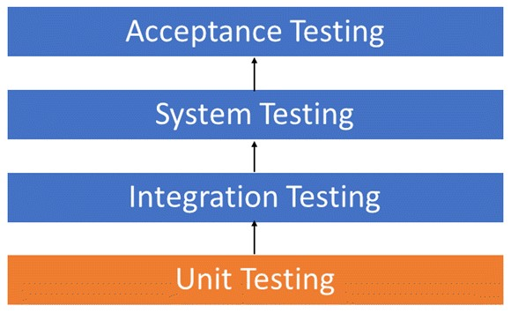

**FUTURE ENHANCEMENT**

These following future enhancements can be made to the project:

1. New flights will be added.

1. Friendlier interface.

1. More Payment methods

**REFERENCES**

While developing the application, reference materials from the following resources were taken:

* [www.youtube.com](http://www.youtube.com/)

* [www.google.co.in](http://www.google.co.in/)